Credit Risk Assessment and Decision Support System with Comprehensive Visualization Using Python and Power BI

ABSTRACT:
Credit risk assessment is a critical component in the financial sector, directly impacting loan approvals, interest rate strategies, and overall risk management. This project, “Credit Risk Assessment and Decision Support System with Comprehensive Visualization Using Python and Power BI”, aims to modernize traditional evaluation methods by integrating machine learning with interactive data visualization. Utilizing Python libraries such as Pandas, Scikit-learn, and Matplotlib, the system processes a real-world credit dataset to train and evaluate predictive models including Logistic Regression, Decision Trees, Random Forest, and Gradient Boosting. Among these, the Random Forest classifier emerges as the most effective, offering high accuracy and reliability in identifying high-risk applicants. The results are visualized in an interactive Power BI dashboard featuring charts, heatmaps, and KPIs, enabling financial stakeholders to interpret credit risk patterns with clarity. This fusion of analytics and visualization empowers data-driven decision-making and lays the groundwork for future enhancements like real-time data integration and cloud deployment.
Keywords:
Credit Scoring, Data Visualization, Machine Learning, Predictive Modelling, Risk Management

CHAPTER-I
INTRODUCTION
1.1 Importance of Credit Risk Management
Credit risk, the possibility that a borrower will fail to meet their repayment obligations, is a fundamental concern in the financial industry. Effective credit risk management is essential for lending institutions to safeguard their profitability, ensure long-term stability, and comply with regulatory requirements. By systematically assessing and mitigating credit risk, financial institutions can minimize loan defaults, optimize resource allocation, and maintain a healthy financial ecosystem. The "Credit Risk Assessment and Decision Support System with Comprehensive Visualization Using Python and Power BI" leverages advanced analytics and visualization to enhance the efficacy of credit risk management.
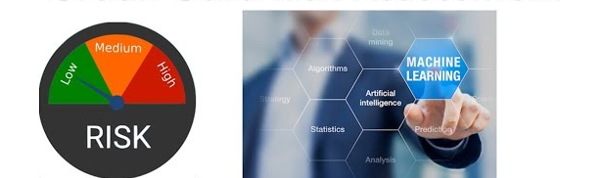Fig 1: Credit card risk assessment
1.1.2 Minimizing Loan Defaults
One of the primary reasons credit risk management is critical is its role in reducing loan defaults. Defaults can lead to significant financial losses, erode capital reserves, and damage an institution’s reputation. By employing predictive models built with Python, such as logistic regression or gradient boosting, the system identifies high-risk borrowers early in the lending process. These models analyze historical data, credit scores, and behavioral patterns to forecast default probabilities. Power BI dashboards then visualize these risk profiles, enabling credit analysts to make informed decisions and implement preventive measures, such as adjusting loan terms or requiring additional collateral.
1.1.3Maintaining Financial Health
Effective credit risk management ensures the financial health of lending institutions by balancing risk and reward. A robust risk assessment framework helps institutions allocate capital efficiently, avoiding overexposure to high-risk borrowers. The proposed system integrates diverse data sources, including credit bureau reports and financial statements, processed using Python libraries like Pandas and NumPy. This allows for a comprehensive evaluation of borrower creditworthiness. Power BI’s interactive visualizations provide clear insights into portfolio performance, highlighting areas of concern and enabling proactive risk mitigation strategies to protect the institution’s bottom line.
1.1.4Regulatory Compliance and Reputation
Regulatory bodies impose stringent guidelines on credit risk management to ensure the stability of the financial system. Non-compliance can result in penalties, increased scrutiny, and reputational damage. The project’s decision support system aids compliance by providing transparent, data-driven risk assessments. Python-based algorithms ensure consistency in evaluating credit applications, while Power BI dashboards offer auditable reports that demonstrate adherence to regulatory standards. A strong risk management framework also enhances an institution’s reputation, fostering trust among customers, investors, and regulators.
1.1.5Enhancing Decision-Making and Competitiveness
Credit risk management empowers financial institutions to make informed lending decisions, improving operational efficiency and competitiveness. The integration of Python’s machine learning capabilities with Power BI’s visualization tools allows stakeholders to explore risk metrics, trends, and borrower profiles interactively. This enables faster, more accurate decision-making, such as approving loans for low-risk borrowers or restructuring terms for those with higher risk. By optimizing lending strategies, institutions can attract reliable borrowers, increase market share, and maintain a competitive edge in the financial industry.
1.2 Limitations of Traditional Methods in Credit Risk Evaluation
Traditional credit risk evaluation methods, often rooted in manual analysis and static scoring models, have been widely used by financial institutions to assess borrower creditworthiness. However, these approaches exhibit significant limitations in today’s dynamic financial landscape. They struggle to capture complex patterns in borrower behavior, lack adaptability to evolving economic conditions, and are often resource-intensive. The "Credit Risk Assessment and Decision Support System with Comprehensive Visualization Using Python and Power BI" addresses these shortcomings by leveraging advanced analytics and interactive visualizations to deliver a more robust and adaptable solution.
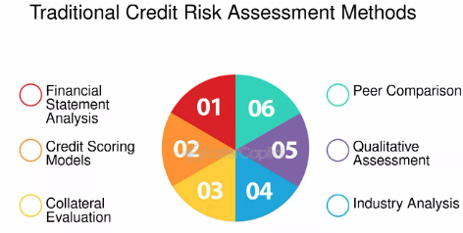
Fig1.2 : Traditional Methods in Credit Risk Evaluation
1.2.1Inability to Capture Complex Patterns
Traditional methods typically rely on static scoring models, such as credit scores or rule-based systems, which evaluate borrowers based on predefined criteria like payment history or debt-to-income ratios. These models often fail to account for nuanced or non-linear patterns in borrower behavior, such as subtle changes in spending habits or correlations between multiple variables. For instance, manual analysis cannot efficiently process large datasets to identify hidden risk factors. In contrast, the proposed system uses Python-based machine learning algorithms, such as random forests or XGBoost, to uncover complex patterns and improve prediction accuracy, with Power BI dashboards visualizing these insights for better decision-making.
1.2.2Lack of Adaptability to Changing Environments
Financial markets are inherently volatile, influenced by economic shifts, regulatory changes, and emerging risks. Traditional methods, built on static models, lack the flexibility to adapt to these changes. For example, a scoring model developed during stable economic conditions may become obsolete during a recession. Manual updates to these models are time-consuming and prone to human error. The project’s system overcomes this by using Python to retrain machine learning models with new data, ensuring adaptability. Power BI’s real-time visualizations allow stakeholders to monitor shifts in risk profiles, enabling proactive adjustments to lending strategies.
1.2.3Resource Intensity and Scalability Issues
Manual credit risk evaluation is labor-intensive, requiring analysts to review applications, verify data, and calculate risk scores. This process is not only time-consuming but also prone to inconsistencies due to human judgment. Additionally, traditional methods struggle to scale with increasing data volumes or borrower diversity. The proposed system automates data processing using Python libraries like Pandas and NumPy, significantly reducing analysis time. Power BI’s interactive dashboards consolidate risk metrics, enabling analysts to focus on high-value tasks rather than repetitive calculations, thus improving scalability and efficiency.
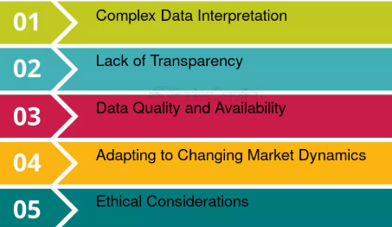
1.2.4Limited Transparency and Stakeholder Engagement
Traditional methods often lack transparency, as static reports and manual processes make it difficult for stakeholders to explore data or understand risk assessments fully. This can hinder collaboration between credit analysts, managers, and regulators. The integration of Power BI in the proposed system addresses this by providing dynamic, user-friendly visualizations that allow stakeholders to drill down into risk factors, compare borrower profiles, and track portfolio performance. This transparency fosters trust and enhances decision-making across the organization.
1.3 Emergence of Data-Driven Techniques in Credit Risk Assessment
The financial industry has witnessed a paradigm shift with the emergence of data-driven techniques, fueled by the availability of large financial datasets and advancements in machine learning. These technologies enable the development of predictive models that assess credit risk with greater accuracy and efficiency compared to traditional methods. The "Credit Risk Assessment and Decision Support System with Comprehensive Visualization Using Python and Power BI" leverages these advancements to identify high-risk borrowers, optimize lending decisions, and enhance risk management through sophisticated analytics and intuitive visualizations.
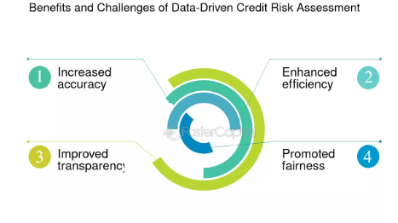
1.3.1Harnessing Large Financial Datasets
The proliferation of digital financial systems has generated vast datasets, including credit bureau reports, transaction histories, and borrower demographics. Unlike traditional methods that rely on limited data points, data-driven techniques process these large datasets to uncover hidden patterns and risk indicators. Python, with libraries like Pandas and NumPy, facilitates efficient data ingestion, cleaning, and transformation, enabling comprehensive analysis of borrower behavior. For instance, variables such as payment frequency, income volatility, and spending patterns can be analyzed to create a holistic risk profile, improving the precision of credit assessments.
1.3.2Advancements in Machine Learning
Machine learning has revolutionized credit risk assessment by enabling the development of predictive models that outperform static scoring systems. Algorithms such as logistic regression, random forests, and gradient boosting (e.g., XGBoost) analyze complex relationships within datasets to predict the likelihood of borrower default with high accuracy. These models, implemented using Python’s Scikit-learn, adapt to new data and evolving financial conditions, ensuring robust performance. By identifying high-risk borrowers early, these models help institutions mitigate potential losses and allocate resources effectively.
1.3.3Improved Accuracy and Efficiency
Data-driven techniques significantly enhance the accuracy and efficiency of credit risk evaluation. Machine learning models can process thousands of data points in seconds, identifying subtle risk factors that manual analysis might overlook. For example, a gradient boosting model can weigh hundreds of features, such as debt-to-income ratios and credit utilization, to generate precise risk scores. The proposed system automates these processes using Python, reducing human error and analysis time. Power BI complements this by visualizing model outputs, enabling analysts to quickly interpret results and make informed decisions.
1.3.4Visualization for Stakeholder Empowerment
The complexity of data-driven models necessitates effective communication of insights to stakeholders. Power BI’s interactive dashboards transform raw data and model predictions into visually appealing, user-friendly reports. These dashboards display key risk metrics, such as default probabilities and portfolio trends, allowing credit analysts, managers, and executives to explore data interactively. This enhances decision-making by providing clear, actionable insights, such as identifying borrowers requiring closer monitoring or adjusting lending strategies to minimize risk.
1.4 Project Objective: Intelligent Credit Risk Assessment System
The primary objective of the "Credit Risk Assessment and Decision Support System with Comprehensive Visualization Using Python and Power BI" is to develop an intelligent, data-driven solution that enhances the accuracy and efficiency of credit risk evaluation in financial institutions. By integrating machine learning algorithms with comprehensive data visualization, the system aims to classify loan applicants based on their risk profiles and provide actionable insights to support informed lending decisions. This project seeks to modernize credit risk management, enabling institutions to mitigate losses, optimize resources, and improve decision-making processes.
1.4.1Developing an Intelligent Credit Risk Assessment System
The core goal is to create a system that leverages advanced machine learning algorithms to assess credit risk with high precision. Using Python, the system employs models such as logistic regression, random forests, and gradient boosting (e.g., XGBoost) to analyze diverse datasets, including credit scores, financial histories, and behavioral patterns. These models classify loan applicants into risk categories (e.g., low, medium, high) based on their likelihood of default. By automating risk assessment, the system reduces reliance on manual processes, minimizing errors and ensuring consistent evaluations.
1.4.2Enhancing Classification Accuracy
A key objective is to improve the accuracy of borrower classification compared to traditional methods. The system processes large datasets using Python libraries like Pandas and Scikit-learn to identify complex patterns and risk indicators, such as debt-to-income ratios or payment irregularities. Machine learning models are trained and validated using metrics like precision, recall, and ROC-AUC to ensure reliable predictions. This enables financial institutions to identify high-risk borrowers early, reducing potential defaults and optimizing loan portfolio performance.
1.4.3Supporting Decision-Making with Comprehensive Visualization
The project aims to empower stakeholders with intuitive, actionable insights through comprehensive data visualization. Power BI is utilized to create interactive dashboards that present key risk metrics, borrower profiles, and portfolio trends in a user-friendly format. These visualizations allow credit analysts, managers, and executives to explore data dynamically, drill down into specific risk factors, and make informed lending decisions. For example, dashboards can highlight trends in default rates or compare risk scores across applicant segments, facilitating strategic planning and risk management.
1.4.4Scalability and Practical Implementation
Another objective is to ensure the system is scalable and adaptable to various financial contexts. The modular design, built on Python’s flexible framework, allows integration with diverse data sources, such as credit bureau reports or internal databases. The system can be customized to accommodate different loan products or regulatory requirements. Power BI’s cloud-based capabilities enable real-time updates and accessibility, ensuring the system remains relevant in dynamic financial environments and supports institutions of varying sizes.
1.5 Use of Python for Model Development in Credit Risk Assessment
Python serves as the backbone for model development in the "Credit Risk Assessment and Decision Support System with Comprehensive Visualization Using Python and Power BI." Its powerful libraries, including Scikit-learn, Pandas, XGBoost, and Matplotlib, enable efficient data preprocessing, training, testing, and optimization of machine learning models for accurate credit risk prediction. By leveraging Python’s robust ecosystem, the system processes complex financial datasets, builds predictive models, and delivers reliable risk assessments to support informed lending decisions.
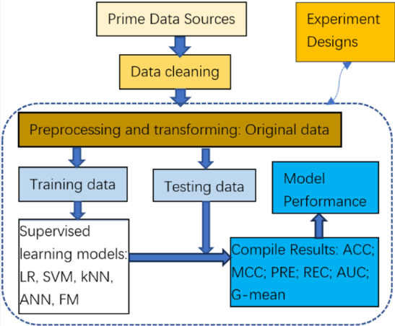
1.5.1Data Preprocessing with Pandas
Effective credit risk modeling begins with high-quality data. Pandas, a versatile Python library, is used for data preprocessing tasks such as ingestion, cleaning, and transformation. The system imports diverse datasets, including credit bureau reports and borrower financial records, and handles missing values, outliers, and inconsistencies. Pandas facilitates feature engineering by creating new variables, such as debt-to-income ratios or payment-to-debt ratios, which enhance model performance. This ensures that the data fed into machine learning models is accurate, consistent, and ready for analysis.
1.5.2Training Models with Scikit-learn
Scikit-learn is employed to develop and train machine learning models for credit risk prediction. The library offers a wide range of algorithms, including logistic regression, decision trees, and random forests, which are used to classify loan applicants based on their default risk. Scikit-learn’s user-friendly interface allows for seamless model training on preprocessed datasets, with features like cross-validation to prevent overfitting. The system evaluates model performance using metrics such as accuracy, precision, recall, and ROC-AUC, ensuring robust and reliable predictions.
1.5.3Optimizing Models with random forest
For enhanced predictive power, the system utilizes random forest , a high-performance gradient boosting library. Random forest excels at handling complex, non-linear relationships in financial data, making it ideal for identifying high-risk borrowers. It optimizes model performance through techniques like regularization and tree pruning, improving both accuracy and computational efficiency. By integrating random forest with Python, the system achieves superior predictive accuracy compared to traditional scoring models, enabling precise classification of loan applicants.
1.5.4Visualization and Analysis with Matplotlib
Matplotlib is used to visualize model outputs and data trends during the development process, aiding in model interpretation and validation. For example, it generates plots such as ROC curves, feature importance graphs, and confusion matrices to evaluate model performance. These visualizations help developers identify key risk factors and refine models iteratively. While Matplotlib supports internal analysis, the system exports final results to Power BI for stakeholder-facing, interactive dashboards, ensuring insights are accessible to non-technical users.
1.6 Model Selection and Evaluation for Credit Risk Prediction
The "Credit Risk Assessment and Decision Support System with Comprehensive Visualization Using Python and Power BI" employs a rigorous model selection and evaluation process to ensure accurate and reliable credit risk predictions. Multiple machine learning models, including Logistic Regression, Decision Trees, Random Forest, and Gradient Boosting, are tested to identify the best-performing model. The selection is based on key performance metrics such as accuracy and F1 score, ensuring the chosen model is robust for deployment and integrates seamlessly with Power BI for visualization of results.
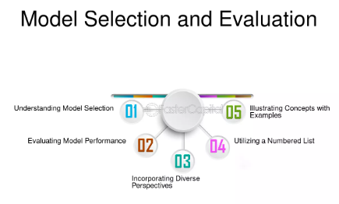
1.6.1Model Selection Process
To develop an effective credit risk prediction system, a variety of models are trained and compared. Logistic Regression serves as a baseline due to its simplicity and interpretability, modeling linear relationships between features like credit scores and default probability. Decision Trees capture non-linear patterns but may overfit, so Random Forest, an ensemble method, is tested to improve robustness by aggregating multiple trees. Gradient Boosting, implemented via XGBoost, is evaluated for its ability to handle complex data patterns through iterative error correction. These models are trained using Python’s Scikit-learn and XGBoost libraries on preprocessed datasets.
1.6.2 Evaluation Metrics
Model performance is assessed using accuracy and F1 score to balance overall correctness and class-specific performance. Accuracy measures the proportion of correct predictions, while the F1 score, the harmonic mean of precision and recall, is critical for handling imbalanced datasets where defaults are less frequent. Additional metrics, such as ROC-AUC and confusion matrices, are used to evaluate model reliability across risk thresholds. Scikit-learn’s cross-validation tools ensure consistent performance across data subsets, reducing overfitting risks and validating generalizability.
1.6.3 Model Testing and Comparison
Each model is tested on a holdout dataset after training on preprocessed data, including features like debt-to-income ratios and payment histories. Logistic Regression provides interpretable results but may underperform on complex patterns. Decision Trees offer flexibility but are prone to overfitting. Random Forest improves stability by reducing variance, while Gradient Boosting often achieves superior performance due to its iterative optimization. Performance metrics are visualized using Matplotlib (e.g., ROC curves) to aid comparison, with results exported to Power BI for stakeholder review.
1.6.4 Selection of the Best-Performing Model
The best-performing model is selected based on the highest accuracy and F1 score, ensuring both overall correctness and effectiveness in identifying high-risk borrowers. For instance, Gradient Boosting (XGBoost) often outperforms others due to its ability to handle non-linear relationships and imbalanced classes. The selected model undergoes hyperparameter tuning (e.g., using grid search in Scikit-learn) to optimize performance. The final model is validated on a separate test set to confirm its robustness before deployment in the credit risk assessment system.
1.7 Data Visualization with Power BI for Credit Risk Assessment
In the "Credit Risk Assessment and Decision Support System with Comprehensive Visualization Using Python and Power BI," Microsoft Power BI serves as the primary tool for creating interactive dashboards that empower stakeholders to explore data patterns, monitor risk metrics, and make informed lending decisions. By leveraging Power BI’s dynamic visual components, such as charts, KPIs, and slicers, the system transforms complex credit risk data into intuitive, actionable insights, enhancing transparency and decision-making efficiency for financial institutions.
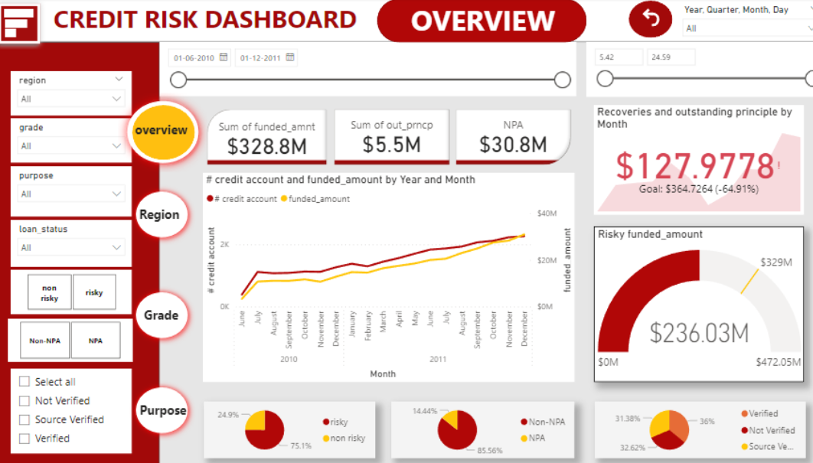
1.7.1 Interactive Dashboards for Stakeholder Engagement
Power BI’s interactive dashboards provide a centralized platform for stakeholders, including credit analysts, managers, and executives, to engage with credit risk data. These dashboards integrate outputs from Python-based machine learning models, such as risk scores and default probabilities, into visually appealing formats. Users can interact with the data through drill-downs, filters, and tooltips, enabling them to explore specific borrower profiles or portfolio trends. This interactivity ensures that stakeholders, regardless of technical expertise, can derive meaningful insights with ease.
1.7.2 Visualizing Patterns with Charts
Power BI’s robust charting capabilities are used to visualize patterns in credit risk data. For example, bar charts display risk distributions across borrower segments, while line charts track trends in default rates over time. Scatter plots highlight correlations between variables, such as credit scores and debt-to-income ratios, helping identify key risk drivers. These visualizations, built using Power BI’s drag-and-drop interface, allow stakeholders to quickly identify high-risk borrowers and understand underlying patterns, facilitating proactive risk management.
1.7.3 Monitoring Risk Metrics with KPIs
Key Performance Indicators (KPIs) in Power BI dashboards provide at-a-glance insights into critical risk metrics, such as portfolio default rates, average risk scores, and loan approval rates. These KPIs are dynamically updated as new data is processed by Python scripts, ensuring real-time monitoring. For instance, a KPI might show the percentage of high-risk loans in the portfolio, alerting stakeholders to potential vulnerabilities. By presenting these metrics in a clear, concise format, Power BI enables rapid assessment of portfolio health and performance.
1.7.4 Dynamic Slicers for Customized Analysis
Power BI’s slicers enhance the system’s flexibility by allowing stakeholders to customize their data views. Slicers enable filtering by criteria such as loan type, borrower demographics, or risk category, tailoring visualizations to specific needs. For example, a manager can use a slicer to focus on high-risk borrowers in a specific region, with charts and KPIs updating instantly to reflect the filtered data. This dynamic functionality supports targeted analysis, helping stakeholders make data-driven decisions aligned with business objectives.
1.8 Integration of Predictive Analytics and Business Intelligence
The "Credit Risk Assessment and Decision Support System with Comprehensive Visualization Using Python and Power BI" seamlessly integrates predictive analytics, powered by Python, with business intelligence, enabled by Power BI. This synergy bridges the gap between complex machine learning models and actionable insights, allowing both technical and non-technical users to interpret model results and underlying data trends effectively. By combining Python’s analytical prowess with Power BI’s intuitive visualizations, the system enhances credit risk assessment and supports data-driven decision-making in financial institutions.
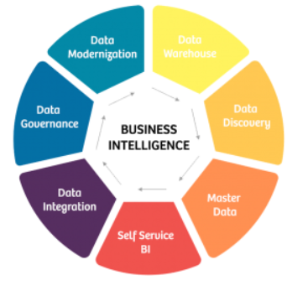

1.8.1 Predictive Analytics with Python
Python serves as the foundation for predictive analytics, leveraging libraries like Scikit-learn, Pandas, and random forest to build robust machine learning models. These models analyze large financial datasets, including credit scores, payment histories, and borrower demographics, to predict default probabilities and classify loan applicants into risk categories. Python’s flexibility enables advanced feature engineering, model training, and optimization, producing accurate risk scores. The system’s predictive outputs, such as default likelihoods and risk rankings, are exported as structured datasets for integration with business intelligence tools.
1.8.2 Business Intelligence with Power BI
Power BI transforms the outputs of Python-based models into interactive, user-friendly visualizations that cater to diverse stakeholders. Its dynamic dashboards feature charts, KPIs, and slicers to present risk metrics, portfolio trends, and borrower profiles in an accessible format. For example, a dashboard might display a heat map of risk scores or a trend line of default rates, enabling non-technical users like managers to grasp insights quickly. Power BI’s drag-and-drop interface and real-time data refresh ensure that visualizations remain current and relevant for decision-making.
1.8.3 Seamless Integration for Enhanced Insights
The integration of Python and Power BI creates a cohesive workflow that maximizes the value of predictive analytics. Python scripts process and analyze data, generating model outputs that are imported into Power BI via data connectors like CSV files or direct database queries. This allows Power BI to visualize complex results, such as feature importance from a Gradient Boosting model or correlations between risk factors, in a way that is intuitive for all users. The system ensures that technical users can refine models while non-technical stakeholders explore insights through interactive dashboards.
1.8.4 Empowering Technical and Non-Technical Users
The project’s design caters to both technical and non-technical audiences. Data scientists can use Python to develop and fine-tune models, leveraging tools like Matplotlib for internal analysis. Meanwhile, non-technical users, such as credit analysts and executives, interact with Power BI dashboards to explore risk trends, filter data by loan type or region, and make informed lending decisions. This dual approach enhances collaboration, ensuring that predictive analytics translate into practical business outcomes without requiring advanced technical expertise.
1.9 Impact and Benefits of the Credit Risk Assessment System
The "Credit Risk Assessment and Decision Support System with Comprehensive Visualization Using Python and Power BI" delivers significant impact and benefits to financial institutions by enhancing operational efficiency, reducing human bias, and enabling real-time monitoring of credit portfolios. By integrating predictive analytics with interactive visualizations, the system empowers stakeholders to mitigate risks effectively and supports strategic planning, ultimately improving financial performance and resilience in a competitive landscape.
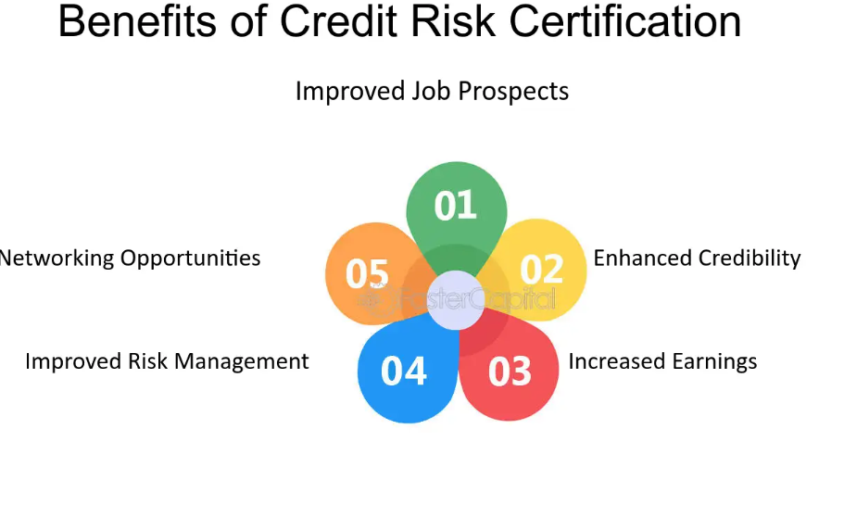

1.9.1 Enhancing Operational Efficiency
The system streamlines credit risk assessment by automating data processing and analysis using Python libraries like Pandas and Scikit-learn. Unlike traditional manual methods, which are time-consuming and labor-intensive, the system processes large datasets and generates risk predictions in seconds. Power BI’s interactive dashboards further reduce the time required for stakeholders to interpret results, allowing credit analysts to focus on high-value tasks like strategy development. This automation and efficiency enable institutions to handle higher loan application volumes without compromising accuracy, boosting overall productivity.
1.9.2 Reducing Human Bias
Human judgment in traditional credit evaluations often introduces bias, leading to inconsistent or subjective decisions. The proposed system mitigates this by relying on data-driven machine learning models, such as Random Forest and XGBoost, which evaluate borrowers based on objective data points like credit scores and payment histories. These models ensure consistent risk assessments across applications. Power BI’s transparent visualizations further enhance fairness by allowing stakeholders to review model outputs and underlying data, reducing reliance on individual discretion and promoting equitable lending practices.
1.9.3 Enabling Real-Time Portfolio Monitoring
Real-time monitoring is critical for managing dynamic credit portfolios. The system integrates Python’s predictive models with Power BI’s real-time data refresh capabilities to provide up-to-date insights into portfolio performance. Dashboards display key metrics, such as default rates, risk score distributions, and portfolio trends, enabling stakeholders to identify emerging risks promptly. For example, a sudden increase in high-risk loans can be flagged instantly, allowing institutions to adjust lending strategies or allocate resources proactively to mitigate potential losses.
1.9.4 Supporting Risk Mitigation and Strategic Planning
By providing accurate risk predictions and actionable insights, the system strengthens risk mitigation efforts. Machine learning models identify high-risk borrowers early, enabling institutions to adjust loan terms or require additional collateral. Power BI’s interactive features, such as slicers and drill-downs, allow stakeholders to explore specific risk factors or borrower segments, facilitating targeted interventions. These insights also support strategic planning by identifying market opportunities, optimizing loan portfolios, and ensuring compliance with regulatory requirements, thereby enhancing long-term financial stability.
1.10 Scope for Future Enhancements in the Credit Risk Assessment System
The "Credit Risk Assessment and Decision Support System with Comprehensive Visualization Using Python and Power BI" provides a robust foundation for credit risk management, but there is significant potential for future enhancements. By incorporating real-time data integration, alternative data sources such as social media or spending patterns, and cloud deployment, the system can further improve its accuracy, adaptability, and accessibility. These enhancements will enhance scalability, enable more nuanced risk assessments, and support remote decision-making, positioning the system for broader adoption and impact.
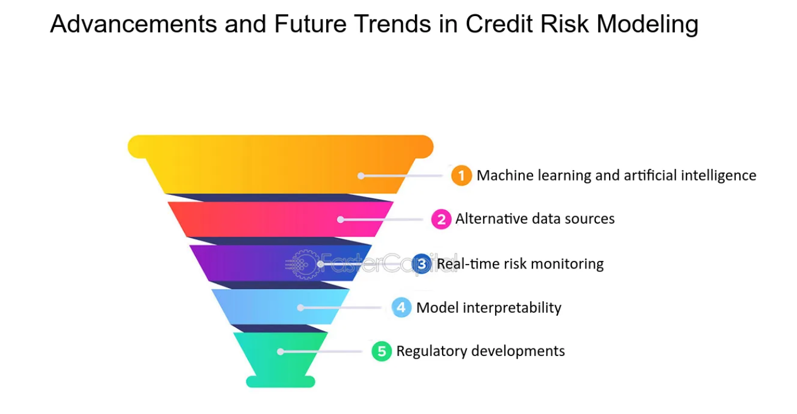
1.10.1 Real-Time Data Integration
Integrating real-time data feeds into the system can enhance its responsiveness to dynamic financial conditions. By connecting to live data sources, such as credit bureau updates or transactional databases, Python scripts can continuously update machine learning models to reflect current borrower behaviors and market trends. Power BI’s real-time data refresh capabilities can then visualize these updates instantly, providing stakeholders with up-to-date risk metrics and portfolio insights. This enhancement ensures timely identification of emerging risks, enabling proactive adjustments to lending strategies and improving overall risk management.
1.10.2 Incorporating Alternative Data Sources
The inclusion of alternative data sources, such as social media activity, spending patterns, or utility payment histories, can enrich the system’s predictive capabilities. These non-traditional datasets provide additional context about borrower reliability, particularly for individuals with limited credit histories. Python libraries like Pandas can process and integrate these diverse data types, while machine learning models, such as random forest , can identify new risk indicators. Power BI dashboards can visualize these insights, for example, by mapping spending trends to risk scores, enabling more comprehensive and inclusive credit assessments.
1.10.3 Cloud Deployment for Scalability
Deploying the system on a cloud platform, such as Microsoft Azure or AWS, can enhance scalability and accessibility. Cloud infrastructure allows the system to handle large datasets and high computational demands efficiently, supporting institutions with growing loan portfolios. Python models can be hosted on cloud services like Azure Machine Learning for seamless retraining and deployment, while Power BI’s cloud-based dashboards enable remote access for decision-makers. This ensures that stakeholders, regardless of location, can interact with real-time visualizations and make informed decisions, improving operational flexibility.
1.10.4 Enhancing Model Adaptability
Future enhancements can focus on making the system more adaptive by incorporating advanced techniques like online learning, where models update incrementally as new data arrives. This can be implemented using Python frameworks like River or TensorFlow. Additionally, integrating explainable AI tools, such as SHAP, can improve model transparency by highlighting key risk factors, fostering trust among stakeholders. These advancements, visualized through Power BI, will ensure the system remains relevant in evolving financial landscapes and regulatory environments

CHAPTER-II
LITERATURE SURVEY
Bussmann,etc.al.This paper presents a comprehensive analysis of how explainable artificial intelligence (XAI) can be integrated into risk management practices in the financial technology (fintech) sector. It discusses the growing demand for transparency and regulatory compliance in AI-based decision-making systems. For the project Credit Risk Assessment and Decision Support System with Comprehensive Visualization Using Python and Power BI, this research provides a vital justification for the use of explainable models in credit scoring. The authors emphasize that trust in AI systems can only be built through transparency, interpretability, and alignment with financial regulations[1]. The study supports incorporating SHAP, LIME, and other XAI methods to interpret machine learning models used in assessing credit risk.

Choi, etc.al. Although RETAIN is designed for healthcare applications, its core mechanism — reverse time attention — offers valuable ideas for building interpretable models in domains with sequential data, such as credit behavior over time. In this project, where customer credit histories may involve temporal patterns (e.g., payment trends), the RETAIN model suggests a way to preserve model performance while enhancing interpretability. It provides a precedent for designing machine learning systems that not only predict accurately but also explain their reasoning in an understandable, user-friendly format. The principles from this model can be adapted to financial datasets to make predictions that financial officers and stakeholders can trust and act upon.

Cohen, etc.al This paper introduces a framework for enhancing the explainability of clustering algorithms using Shapley values. While the study focuses on fault diagnosis, its approach to transparency in unsupervised learning can be extended to risk profiling in credit assessment. In Credit Risk Assessment and Decision Support, clustering techniques are often used to segment borrowers by risk levels. The integration of Shapley-based XAI ensures that these groupings are not black-box outcomes but are instead based on traceable and logical factors. This strengthens stakeholder confidence in the segmentation and supports regulatory requirements for explainable modeling in credit systems.

de Lange, etc.al This study addresses the direct application of explainable AI techniques in the banking sector for credit assessment. It evaluates how SHAP and LIME can improve the transparency of machine learning models used by banks to predict creditworthiness. For your project, this research provides a blueprint for integrating these interpretability tools into predictive pipelines, making them accessible via Power BI dashboards. The paper emphasizes that explainability not only improves trust among decision-makers but also fulfills increasingly stringent audit and compliance standards. It aligns perfectly with your system's goal to combine algorithmic risk prediction with visual, interpretable analytics for end users.

Demajo, etc.al This work explores how explainable AI can be used to build transparent credit scoring systems. It emphasizes that as machine learning becomes integral to lending decisions, the need for fairness, interpretability, and accountability becomes critical. The authors recommend combining statistical techniques with AI to create hybrid models that are both robust and explainable. For your project, this directly supports the integration of transparent models using Python alongside visual interpretation tools like Power BI. The emphasis on ethical AI also resonates with the need for responsible credit decision-making, especially in regulated environments like banking and microfinance.

Doersch,etc.al This tutorial provides a deep dive into variational autoencoders (VAEs), which are unsupervised learning models capable of capturing latent features in data. Although not specific to finance, VAEs can be used in credit risk assessment to detect hidden patterns in borrower behavior that may not be evident through conventional models. For your project, this opens the door to advanced modeling techniques that go beyond traditional classification, potentially adding an extra layer of risk profiling. When integrated with Power BI, the latent factors discovered via VAEs could also be visualized to uncover trends among high-risk borrowers.

European Union, etc.al This regulation mandates that financial institutions collect detailed, granular credit data for better supervision and risk monitoring. In the context of your project, it provides a legal and regulatory foundation for why systems like yours must not only assess credit risk accurately but also document and explain their predictions. The regulation supports your use of explainable AI and business intelligence tools to ensure the outputs of machine learning models are transparent, traceable, and auditable. Using Power BI for visualization aligns with the regulation’s call for clear, detailed reporting that can be reviewed by regulators and internal compliance teams.

Fahner, etc.al Fahner’s paper discusses the creation of interpretable credit risk scorecards using XAI techniques. Traditional scorecards, while transparent, often lack predictive power; AI models, while powerful, are often opaque. This study bridges that gap by using SHAP and other tools to create scorecards that offer the best of both worlds. Your project benefits directly from this approach, as it aims to balance model accuracy with visual clarity in Power BI. The work supports the use of feature importance plots and dashboard indicators that can help analysts justify loan decisions and respond to audits or customer concerns with data-backed explanations.

Galindo, etc.al This foundational paper compares traditional statistical methods with newer machine learning approaches in the domain of credit risk modeling. It offers insight into model selection, data preparation, and evaluation, serving as a methodological guide for your project. It underlines the importance of balancing interpretability with accuracy, a principle that your project reflects by integrating machine learning models in Python with intuitive data visualizations in Power BI. The paper’s lessons on model validation and cross-method comparisons remain highly relevant in the development of modern, hybrid risk assessment systems.

Giudici, etc.al This study introduces an innovative method that combines fairness analysis (via Lorenz curves) with model interpretability (via Shapley values). It is particularly relevant to systems like yours, where lending fairness and variable importance must be carefully balanced. The Shapley-Lorenz decomposition allows for both technical and ethical assessment of credit scoring models, ensuring that decisions are not only accurate but also non-discriminatory. In the context of your project, incorporating such fairness-aware explainability could improve trust in the system and satisfy ethical guidelines on fair lending.

CHAPTER-III
Credit Risk Assessment and Financial Decision Support Using Explainable Artificial Intelligence
One of the major problems faced by financial organizations is risk management, particularly credit risk management. Technological advancements are making it possible to analyze an abundance of client data, thereby reducing lending risks for banks. The available data are analyzed and reduced to a single quality metric, known as a credit score, using statistical and machine learning (ML) approaches. High predictive accuracy in determining a customer’s credit risk has been demonstrated with the use of sophisticated machine learning algorithms. However, these innovative and cutting-edge methods lack the transparency required to display how and why a specific borrower is approved for a loan or not. Specifically, these models are produced by an algorithm straight from data. In financial services businesses, data are viewed as a key strategic asset and a source of competitive advantage. The application of AI models to utilize data offers several benefits. Financial services that must abide by specific rules are not appropriate for black box artificial intelligence (AI).
Explainable AI models that include specifics or justifications to make AI action trans- parent or understandable are required to solve this issue. Explainable AI (XAI) refers to the design and development of artificial intelligence (AI) systems that can provide under- standable and interpretable explanations for their decisions or predictions. Traditional AI models, such as deep learning neural networks, often function as black boxes, meaning that they generate results without clear explanations of how those results were reached. This lack of transparency can be problematic, especially in critical applications such as healthcare, finance, and autonomous vehicles, where trust, accountability, and fairness are crucial. Credit risk analysis utilizing explainable AI makes use of machine learning models and algorithms that produce clear and understandable outcomes. To create such models, it is first necessary to comprehend what “explainable” means in this context. At the institutional level, significant benchmark definitions have been offered this year. We discuss a few of these proposed in the European Union.
The European GDPR European Union (2016) regulation states that “The existence of automated decision-making should be accompanied by meaningful disclosure of the underlying logic, as well as the significance and intended effects of such processing on the data subject”. The Bank of England states Joseph (2020) that “Explainability means that an interested stakeholder can comprehend the main drivers of a model-driven decision”. The Financial Stability Board (FSB) Bussmann et al. (2020) suggests that “lack of interpretability and auditibility of AI and ML methods could become a macro-level risk”. The Ethics Guidelines for Trustworthy Artificial Intelligence were finally released in April 2019 by the High-Level Expert Group on AI of the European Commission. To be considered trustworthy, AI systems must adhere to a set of seven essential criteria presented in these guidelines
Various Aspects of XAI
Among the seven aforementioned criteria, the following three are connected to XAI:
Human agency and oversight: Judgments must be informed, and human monitoring is required.
Transparency: AI system decisions should be conveyed in a form that is suitable for the relevant stakeholder. People need to be aware that they are engaging with artificial intelligence systems.
Accountability: Mechanisms for accountability, auditability, and assessment of algo- rithms, data, and design processes must be implemented in AI systems. To improve decision making and risk assessment, it is important to comprehend the elements and characteristics that influence credit risk projections.
Major Contributions of the Proposed Work
The major contributions of the proposed work are as follows:
Analysis of the feature importance and significance in determining model output.
Presentation of a model in both local and global surrogates.
Presentation of both a classification analysis and a regression analysis.
XAI scenarios for both acceptance and rejection, along with a description of the features.
A description of the preprocessing and feature selection techniques used to ensure accurate classification without any class imbalances.

Structure of the Work
Data gathering and preparation: We assemble pertinent credit information, such as client details, credit history, bank documents, and transactional records. The data are preprocessed by cleaning, normalized, and formatting to allow their use in analysis.
Feature engineering: We extrapolate useful characteristics from the data that can be used to forecast credit risk. The characteristics of the consumer, their income and job history, the quantity of the loan, their credit utilization ratio, their payment history, and other factors could be among these. We ensure that the features are relevant, informative, and nonredundant.
Model selection: It is important to choose a machine learning algorithm or model that can provide explainable results. Popular algorithms for credit risk analysis include logistic regression, decision tree, random forest, and gradient boosting models. These algorithms often provide feature importance measures that can be used to interpret the model’s predictions.
Training the model: After splitting the data into training and testing sets, we use the training set to train the chosen model on historical credit data. During this phase, the model learns patterns and relationships between features and credit risk outcomes.
Model interpretation: After training, the model’s feature importance scores or coeffi- cients are analyzed. These values indicate the relative importance of each feature in predicting credit risk. Higher values suggest stronger influences, while lower values suggest weaker influences.
Model evaluation: We assess the performance of the model on the testing set by using appropriate evaluation metrics such as accuracy, precision, recall, and F1-score to evaluate the model’s predictive power, generalization ability, and reliability.
Model deployment and monitoring: After evaluating the model, we deploy it for credit risk analysis. We continuously monitor the model’s performance and periodically retrain it with new data to maintain accuracy and adapt to changing credit risk patterns.
Explanations and insights: We provide explanations for the model’s predictions. This could involve explaining why a particular applicant is classified with a high or low credit risk by highlighting the significant factors influencing the decision. For this, we utilize techniques such as feature importance plots, partial dependence plots, and individual instance explanations to enhance transparency. The explainability of an AI model is crucial in credit risk analysis, as it is important to gain the trust of stakeholders and ensure compliance with regulations. XAI enables lenders, regulators, and customers to understand the reasoning behind credit decisions and identify any potential biases or unfair practices.

Literature review:
Model interpretation refers to the process of understanding and explaining the inner workings and decision-making methods of a machine learning model Mestikou et al. (2023). It involves analyzing the model’s predictions, understanding the status of input features, and gaining insights into how the model arrives at its decisions. Various techniques can be applied to understand and to interpret the models in a more precise manner. The distinct characteristics of AI models, together with increased processing capacity, make new sources of information (big data) available for creditworthiness assessments. When used together, AI and big data can detect weak signals, such as interactions or nonlinearity across explanatory variables, which appear to improve prediction over traditional creditworthiness metrics. At the macroeconomic level, this translates into good economic growth projections. On a smaller scale, the use of AI in credit analysis enhances financial inclusion and loan access for previously underserved borrowers. However, due to potential biases and ethical, legal, and regulatory issues, AI-based credit analysis systems present long-term concerns. These constraints need the implementation of a new generation of financial regulations as per the paper Sadok et al. (2022).
AI (artificial intelligence) is a key technological innovation that is generating a lot of excitement due to its enormous potential. Researchers have assessed the impact of supervised artificial intelligence techniques, i.e., machine learning techniques, on Pakistani nonfinancial enterprises, and focus on the practical application of AI techniques for accurate prediction of corporate hazards being automated, resulting in the automation of corporate risk management. They employed financial ratios to accurately assess risk and automate corporate risk management by building machine learning algorithms employing techniques such as random forest, decision tree, naive Bayes, and KNN, as per the paper Hu and Su (2022). The credit risk analysis can be rendered with greater support by XAI Giudici and Raffinetti (2020); Misheva et al. (2021) and de Lange et al. (2022). Benchmarking approaches for machine learning models are investigated in the paper Vincenzo Moscato (2021). A review of various aspects of XAI is presented in the paper Heng and Subramanian (2022). The General Data Protection Regulation (GDPR) and the Equal Credit Opportunity Act (ECOA) have added explainability for the right to explanation policy in the proposed work Demajo et al. (2020). The application of the SHAP values with various plots for 20 features is presented by the work Torrent et al. (2021). The contributions of LIME and Shapley values for credit risk analysis are investigated in the paper Gramegna and Giudici (2021). Banks do not have to decrease prediction accuracy for model transparency to meet regulatory standards. With the demonstration, a black box model’s forecasts of credit losses can be simply explained in terms of their inputs. Because black box models are better at detecting complex patterns in data, banks should include the credit loss determinants identified by these models in lending choices and credit exposure pricing. XAI models for credit loss with regression analysis are given in the paper Bastos and Matos (2022). The work of financial technical management with credit analysis of 15,000 small and medium companies was carried out using the SHAPELY XAI tool. Lending operations, particularly for small and medium-sized firms (SMEs), are increasingly dependent on financial technologies and were addressed by the authors of Bussmann et al. (2020).
Year | Reference | Methods / Focus | Highlights
2025 | Shreya & Pathak (arXiv 2025) | XGBoost, LightGBM, Random Forest + SHAP & LIME | Ensemble models with XAI; SMOTE balancing; applicant-specific visual reports (arXiv)
2025 | Raymond Ajax (ResearchGate, Jun 2025) | Ensemble & Deep Learning + SHAP & LIME | Compares traditional vs modern models; policy/practical recommendations
2024 | Mainuddin Adel Rafi et al. (JEFAS Feb 2024) | SHAP, LIME + ensemble & decision trees | Public datasets; AUC-ROC comparisons; trust-building framework
2024 | Nallakaruppan et al. (Applied Soft Computing, 2024) | XAI framework for credit evaluation | Identifies top features via SHAP/LIME; detailed interpretability
2025 | Joshi (Preprints.org Mar 2025) | Review of gradient boosting + XAI in finance | Surveys literature on boosting + explainability
2025 | Springer review (Model-Agnostic XAI in Finance) | SHAP, LIME, post-hoc techniques | Comparative survey; scalability, accuracy, regulatory alignment
2025 | ArXiv: Interpretable LLMs for Credit Risk | LLMs + chain-of-thought + natural-language explanations | Taxonomy of LLM interpretability in credit risk
2024 | MDPI Applied: Hybrid model with LIME/SHAP | Extra Trees + ANOVA + SMOTE + XAI visuals | Multi-class dataset; solid metrics (~80% accuracy)

With the emphasis on both global and local surrogates, with the implementation of model-based and model-agnostic, and with the presence of LIME and Shapley implementa- tion with feature importance analysis, the proposed work provides better modeling and analysis compared with the existing works discussed in Table 1.
The Figure 1 illustrates a pie chart of various research papers and technologies dis- cussed, highlighting the key areas of focus within the surveyed topics.
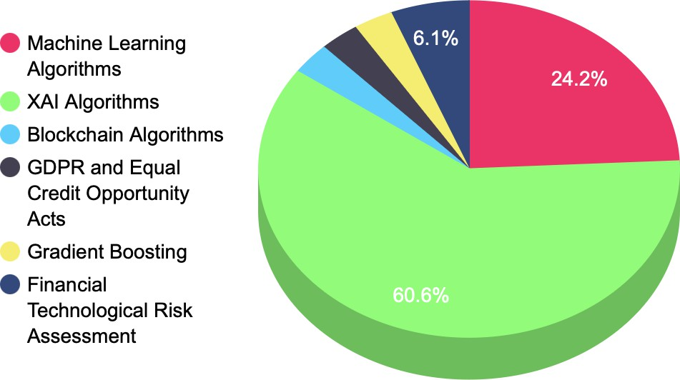
System model and architecture
Figure 2, mentioned above, shows a diagram depicting the functionality of the credit risk evaluation system. The customers avail of various loan products like credit cards, car loans etc. The application arrives at the bank, through e-document, for further processing. These requests are formulated as a dataset from the bank’s server. This dataset is prepro- cessed and classified into 13 features that are relevant for the credit risk assessment. These features are classified into two classes based on the credit report analysis, that is, the loan is accepted or rejected.

AI (artificial intelligence) is a key technological innovation that is generating a lot of excitement due to its enormous potential. Researchers have assessed the impact of supervised artificial intelligence techniques, i.e., machine learning techniques, on Pakistani nonfinancial enterprises, and focus on the practical application of AI techniques for accurate prediction of corporate hazards being automated, resulting in the automation of corporate risk management. They employed financial ratios to accurately assess risk and automate corporate risk management by building machine learning algorithms employing techniques such as random forest, decision tree, naive Bayes, and KNN, as per the paper Hu and Su (2022). The credit risk analysis can be rendered with greater support by XAI Giudici and Raffinetti (2020); Misheva et al. (2021) and de Lange et al. (2022). Benchmarking approaches for machine learning models are investigated in the paper Vincenzo Moscato (2021). A review of various aspects of XAI is presented in the paper Heng and Subramanian (2022). The General Data Protection Regulation (GDPR) and the Equal Credit Opportunity Act (ECOA) have added explainability for the right to explanation policy in the proposed work Demajo et al. (2020). The application of the SHAP values with various plots for 20 features is presented by the work Torrent et al. (2021). The contributions of LIME and Shapley values for credit risk analysis are investigated in the paper Gramegna and Giudici (2021). Banks do not have to decrease prediction accuracy for model transparency to meet regulatory standards. With the demonstration, a black box model’s forecasts of credit losses can be simply explained in terms of their inputs. Because black box models are better at detecting complex patterns in data, banks should include the credit loss determinants identified by these models in lending choices and credit exposure pricing. XAI models for credit loss with regression analysis are given in the paper Bastos and Matos (2022). The work of financial technical management with credit analysis of 15,000 small and medium companies was carried out using the SHAPELY XAI tool. Lending operations, particularly for small and medium-sized firms (SMEs), are increasingly dependent on financial technologies and were addressed by the authors of Bussmann et al. (2020). Machine learning models are opaque and difficult to explain, which are important components for developing a dependable technology. The research compares single classifiers (logistic regression, decision trees, LDA, QDA), heterogeneous ensembles (AdaBoost, random forest), and sequential neural networks. Ensemble classifiers and neural networks outperform others, according to the results. Furthermore, two powerful post hoc modelagnostic explainability tools—LIME and SHAP—were used to evaluate ML-based models in Tyagi (2022). The study proposed by Galindo and Tamayo (2000) involved a comparative analysis of statistical and machine learning methods, introducing a novel modeling approach based on error curves. More than 9000 models were built, with the findings highlighting CART decision tree models as the most effective, boasting an average 8.31% error rate. This work emphasized the limitations associated with data availability, suggesting a potential 7.32% error rate with a larger dataset. While neural networks and K-nearest neighbor outperformed the standard Probit algorithm, it is important to approach the interpretation of results cautiously. This work underscores the potential of XAI in enhancing credit risk assessment and stresses the importance of addressing data limitations for more accurate predictions. The authors of Biecek et al. (2021) suggested that leveraging advanced modeling techniques presents an opportunity to improve credit scoring analytics, underscoring the difficulty of balancing accuracy and interpretability. Their study compared various predictive models, such as logistic regression, logistic regression with weight of evidence transformations, and modern artificial intelligence algorithms, highlighting the superior predictive capability of advanced tree-based models in anticipating client default. To tackle the interpretability challenge linked with black box models, the authors showcased methods to enhance accessibility for credit risk practitioners. While the approach enhances model accuracy, its drawback lies in potential implementation and interpretation complexities, particularly in widespread deployment.
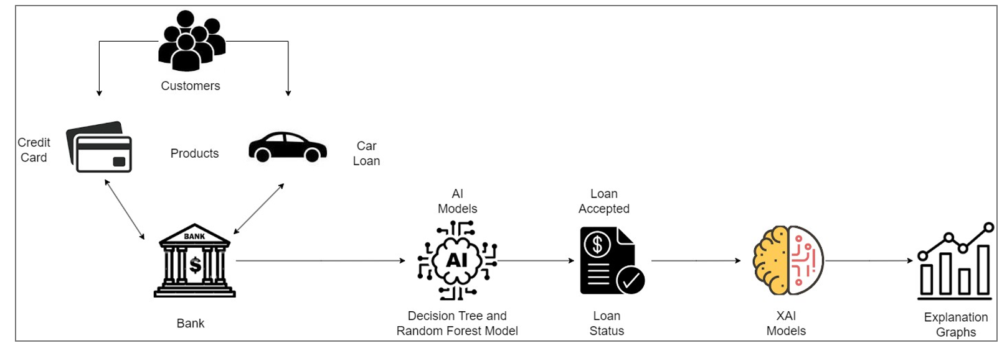
These features are classified by two algorithms: a decision tree and a random forest, the output of which is further explained by the XAI models LIME and SHAP values. The LIME model explains how features develop relationships with each other in local surrogates, which means how the feature importance and relationships are explained for the instance of the dataset. This tool also helps us to evaluate the importance of these features for the prediction of the target attribute. The SHAP values explain the dependency of the features and their significance in determining the target in both global and local surrogates. This uses various plots to describe the relationship between the target attribute with independent features, such as the summary plot, dependency plot, and decision plot. These plots explain the overall dataset and the loan classification problem. The results are discussed in the next section in detail with relevant models of interest.
  - System Model:
This section deals with the various mathematical models which are present in the work such as decision trees, random forest machine learning models, and the LIME and SHAP explainability models.
  - Decision Tree:
Decision tree is a supervised learning algorithm that works for both classification and regression problems. It contains the structure as per the name, that is a tree with nodes, where the branches are formed up for certain criteria. The decision tree separates the branches until it reaches the threshold criteria for the decision. The decision tree contains the root node, leaf node, and child nodes. The recursion is carried out through node traversal. This can work with any linear model without the support of any other algorithm. This handles the large volume of the data with less time. This contains various processes like the following:
- Splitting: When a dataset is supplied to the tree, it divides by splitting the dataset into various categories.
- Pruning: It works for the shredding of the trees. Furthermore, it works for classification by subsiding the data in a better way. The pruning ends when the leaf node is reached.
- Selection: The best tree model is selected from the available trees that works smoothly foru the data. This selection is based on the below factors.
- Entropy: This is the measure of the homogeneity of the trees. If the trees are homoge- neous, then it would be zero.
- Information gain: When the entropy decreases, the information gain increases; this allows a further split of the trees into branches for further classification.

The entropy of the decision tree is explained as per Equation (1). In the E(X), where X is the state of the decision tree and Pi is the probability of an instance, the entropy is represented as per Equation (1).

E(X) = ∑ −Pi logPi

The information gain is represented as the difference between the entropy before splitting a node and after splitting the node as per Equation (2).

In f o − g = E(T) − E(T, X)

where E(T) is the tree node before splitting. Finally, the Gini index is the measure of the sum of the class probabilities from one. This is the cost function that estimates the efficiency of the splitting. The Gini index is represented as G_{i} for the probability function Pi, which is expressed as per Equation (3).
Gi = 1 − ∑Pi
Algorithm 1: Algorithm for credit explanation.
1 n ← numbero f Instances;
2 P_{i} ← Probabilityo f theEvent;
3 EstimateEntrophy;
4 $E\left(X\right)=\sum^{n}{}-Pi llog$
i=1
6 Gi = 1 − ∑^{n} Pi ;
i=1
7 R ← Contributing f eatures;
8 x ← Complexity f unction;
9 i ← orgin j ← lassoestimator f ← surrogacy f unction;
10 w ← Loss f unction;
11 y ← Value f unction;
12 v ← value f unctiono f theplayers;
13 RFR ← RandomForestRegressor
14 if RFR is local then

15 L(j) ← Loss f unction;
16 exp ← θ(j) = L( f , i, π_{j}) + ω(i);
17 Decision Explained with Local Surrogates
18 else
19 RFR is global
20 θ(z) = ∑_{x⊂Ri} |x|!(R − |x| − 1)!/R! ∗ (y(X ∪ i − V(x));

CHAPTER-IV
Proposed Solution for Credit Risk Assessment and Decision Support System
Using Python and Power BI
The "Credit Risk Assessment and Decision Support System with Comprehensive Visualization Using Python and Power BI" aims to deliver an intelligent, scalable, and user-friendly solution for financial institutions to evaluate credit risk, predict loan defaults, and support decision-making. This proposed solution outlines a comprehensive approach to implement the system, leveraging Python for predictive analytics and Power BI for interactive visualizations. It addresses data preprocessing, model development, evaluation, integration, and visualization, while incorporating future enhancements for scalability and adaptability.
System Architecture
The system follows a modular architecture:
- Data Ingestion and Preprocessing: Python scripts handle data collection, cleaning, and feature engineering.
- Predictive Modeling: Machine learning models are developed and evaluated to predict credit risk.
- Integration with Power BI: Model outputs are exported to Power BI for visualization and stakeholder interaction.
- Deployment and Scalability: The system is designed for cloud integration and real-time updates.
1. Data Ingestion and Preprocessing
Objective: Prepare high-quality data for modeling by cleaning and transforming financial datasets.
- Tools: Python libraries (Pandas, NumPy).
- Process:
  - Data Sources: Import datasets such as credit bureau reports, loan application data, and financial statements (e.g., CSV, Excel, or SQL databases).
  - Data Cleaning: Handle missing values (e.g., impute with median for numerical data, mode for categorical), remove duplicates, and correct inconsistencies (e.g., date formats).
  - Feature Engineering: Create features like debt-to-income ratio, credit utilization, and payment-to-income ratio. Encode categorical variables (e.g., one-hot encoding for education level or gender).
  - Data Transformation: Normalize numerical features (e.g., using StandardScaler) and split data into training (80%) and testing (20%) sets.
- Output: A clean, processed dataset ready for modeling, stored as a Pandas DataFrame.
2. Predictive Modeling with Python
Objective: Develop and optimize machine learning models to predict credit risk (probability of default).
- Tools: Scikit-learn, XGBoost, Matplotlib.
- Model Selection:
  - Train multiple models: Logistic Regression (baseline), Decision Trees, Random Forest, and Gradient Boosting (XGBoost).
  - Logistic Regression: Models linear relationships, interpretable for regulatory compliance.
  - Decision Trees: Captures non-linear patterns but may overfit.
  - Random Forest: Reduces overfitting through ensemble learning.
  - Gradient Boosting (XGBoost): Optimizes predictive accuracy for imbalanced datasets.
- Implementation:
  - Use Scikit-learn for Logistic Regression, Decision Trees, and Random Forest.
  - Implement Random forest.
  - Handle class imbalance (common in credit risk data) using techniques like SMOTE or class weighting.
- Outcome: Trained models with performance metrics (accuracy, F1 score, ROC-AUC).
3. Model Evaluation and Selection
Objective: Identify the best-performing model for deployment.
- Evaluation Metrics:
  - Accuracy: Measures overall correctness.
  - F1 Score: Balances precision and recall, critical for imbalanced datasets.
  - ROC-AUC: Assesses model discrimination between default and non-default cases.
- Process:
  - Perform 5-fold cross-validation to ensure generalizability (using Scikit-learn’s cross_val_score).
  - Visualize performance using Matplotlib (e.g., ROC curves, confusion matrices).
  - Select the model with the highest F1 score and ROC-AUC, typically XGBoost for its ability to handle complex patterns and imbalanced data.
- Outcome: XGBoost selected as the best model, with outputs saved as CSV for Power BI integration.
4. Integration with Power BI
Objective: Visualize model outputs and risk metrics for stakeholder decision-making.
- Tools: Power BI Desktop, Python integration.
- Process:
  - Data Export: Save model predictions (e.g., risk scores, default probabilities) as CSV files using Pandas.
  - Power BI Import: Import the CSV into Power BI via “Get Data” > “Text/CSV” or use Python script integration (pandas.read_csv in Power BI’s Python script editor).
  - Dashboard Design:
    - Create interactive dashboards with charts (e.g., bar charts for risk score distributions, line charts for default trends).
    - Use KPIs to display portfolio metrics (e.g., default rate, average risk score).
    - Implement slicers for filtering by loan type, borrower demographics, or risk category.
  - Visualization Example:
    - Bar chart: Risk score distribution across borrowers.
    - Scatter plot: Credit score vs. debt-to-income ratio, colored by default probability.
    - KPI: Percentage of high-risk loans in the portfolio.
- Outcome: Interactive Power BI dashboards that enable stakeholders to explore risk metrics and make informed decisions.
5. Benefits and Impact
- Operational Efficiency: Automates data processing and risk assessment, reducing manual effort.
- Reduced Bias: Data-driven models minimize subjective decision-making.
- Real-Time Monitoring: Power BI’s real-time refresh enables continuous portfolio oversight.
- Strategic Planning: Insights from dashboards support loan policy adjustments and risk mitigation.
6. Future Enhancements
- Real-Time Data Integration: Connect to live data feeds (e.g., APIs for credit bureau updates) using Python’s requests library and Power BI’s streaming datasets.
- Alternative Data Sources: Incorporate social media or spending patterns, processed with Python’s text analysis libraries (e.g., NLTK).
- Cloud Deployment: Deploy models on Azure Machine Learning for scalability, with Power BI hosted on Power BI Service for remote access.
- Explainable AI: Use SHAP to provide feature importance explanations, visualized in Power BI for transparency.
7. Implementation Considerations
- Environment Setup: Install Python 3.7+ with Pandas, Scikit-learn, XGBoost, and Matplotlib. Use Power BI Desktop with Python integration enabled.
- Security: Ensure data privacy by anonymizing sensitive information (e.g., using Pandas to mask credit card numbers).
- Scalability: Optimize Python scripts for large datasets and leverage Power BI’s cloud capabilities for enterprise deployment.

UML DIAGRAM :
Use Case Diagram
This diagram shows interactions between users and the system’s core functionalities — such as uploading data, training the model, viewing predictions, and visualizing in Power BI.
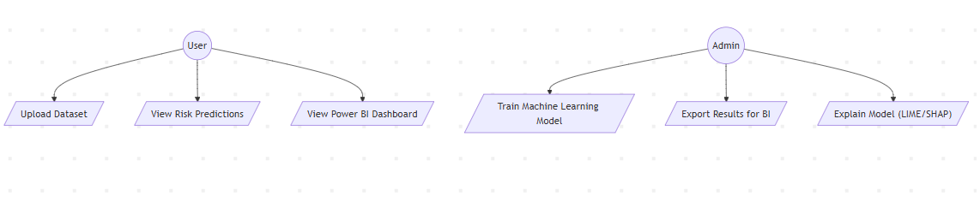
Overview of the UML Diagram
The provided UML diagram represents a simplified use case model, which outlines the interactions between actors (User and Admin) and the system functionalities they can perform. This type of diagram is commonly used in software engineering to depict the functional requirements of a system from the perspective of its users. The diagram includes two primary actors—User and Admin—connected to various use cases that define their roles and capabilities within the system. The use cases are categorized based on the tasks each actor can execute, suggesting a system designed for data management, machine learning model training, and result analysis, likely in a business intelligence (BI) or risk assessment context.
The diagram’s layout is hierarchical, with the User and Admin actors branching out to their respective use cases. This structure indicates a division of responsibilities, where the User has access to data interaction and visualization functionalities, while the Admin has additional privileges for training models and exporting or explaining results. The use of arrows from actors to use cases signifies that these actors initiate the described actions, providing a clear flow of interaction.

Actors in the Diagram
User
The User actor represents an individual or entity interacting with the system at a basic level. This actor is likely an end-user who relies on the system for data input, viewing predictions, or accessing dashboards. The User is associated with three specific use cases:
- Upload Dataset: This use case allows the User to input data into the system, possibly in the form of files or streams, which serves as the foundation for subsequent analyses or predictions.
- View Risk Predictions: This functionality enables the User to access and review risk-related forecasts or outcomes generated by the system, indicating a risk assessment or predictive analytics component.
- View Power BI Dashboard: This use case suggests integration with Microsoft Power BI, a popular business intelligence tool, allowing the User to visualize data and insights in an interactive dashboard format.
The User’s role appears to be focused on data consumption and basic interaction, implying a non-technical audience or a role with limited administrative privileges.
Admin
The Admin actor represents a higher-privilege user, such as a system administrator or data scientist, with extended capabilities beyond those of the User. The Admin is linked to three use cases:
- Train Machine Learning Model: This use case indicates that the Admin can develop or train machine learning models using the uploaded datasets, suggesting a technical role responsible for model creation and optimization.
- Export Results for BI: This functionality allows the Admin to extract and prepare results for integration into business intelligence tools, facilitating further analysis or reporting.
- Explain Model (LIME/SHAP): This use case involves using techniques like LIME (Local Interpretable Model-agnostic Explanations) or SHAP (SHapley Additive exPlanations) to interpret and explain the predictions or behaviors of the machine learning models, highlighting a focus on model transparency and interpretability.
The Admin’s responsibilities suggest a more technical and managerial role, overseeing the system’s analytical capabilities and ensuring the models are both effective and understandable.
Use Cases and Their Implications
User Use Cases
- Upload Dataset
  - Description: The User initiates the process of uploading a dataset, which could involve selecting files from a local system or importing data from an external source. This step is critical as it provides the raw material for the system’s predictive and analytical functions.
  - Implication: This use case implies a user-friendly interface for data ingestion, possibly with support for various file formats (e.g., CSV, Excel) and data validation checks to ensure quality.
- View Risk Predictions
  - Description: The User can access risk predictions, which are likely generated by a pre-trained machine learning model. This could include risk scores, probabilities, or categorized outcomes relevant to a specific domain (e.g., financial risk, health risk).
  - Implication: The system must include a robust prediction engine and a visualization layer to present results in an accessible manner, catering to users who may not have deep technical expertise.
- View Power BI Dashboard
  - Description: This use case integrates the system with Power BI, allowing the User to explore data through interactive dashboards. These dashboards might include charts, graphs, and filters to analyze trends or key performance indicators.
  - Implication: The system requires an API or export mechanism to connect with Power BI, indicating a focus on business intelligence and decision-making support.
Admin Use Cases
- Train Machine Learning Model
  - Description: The Admin can train machine learning models using the uploaded datasets. This process involves selecting algorithms, tuning hyperparameters, and validating the model’s performance.
  - Implication: This use case suggests a sophisticated backend with machine learning libraries (e.g., scikit-learn, TensorFlow) and a user interface for model configuration, aimed at technical users.
- Export Results for BI
  - Description: The Admin can export processed results, such as model predictions or statistical summaries, in a format compatible with BI tools like Power BI.
  - Implication: This requires a data export pipeline with support for standardized formats (e.g., JSON, CSV) and possibly automated workflows to streamline integration.
- Explain Model (LIME/SHAP)
  - Description: The Admin can use LIME or SHAP to provide explanations for the model’s predictions, helping to understand feature importance or local decision-making processes.
  - Implication: This use case highlights a focus on interpretability, which is crucial in regulated industries (e.g., finance, healthcare) where model transparency is required by law or best practices.
Relationships and System Design Considerations
The UML diagram uses a simple association relationship between actors and use cases, indicated by the arrows. This suggests a direct interaction without complex dependencies or preconditions between the use cases. However, the division between User and Admin use cases implies a role-based access control (RBAC) system, where permissions are assigned based on the actor’s identity.
- Separation of Concerns: The clear distinction between User and Admin functionalities indicates a design that separates data consumption (User) from data processing and model management (Admin). This enhances security and usability by limiting access to sensitive operations.
- Scalability: The inclusion of Power BI integration and machine learning training suggests a scalable architecture that can handle growing datasets and complex computations, potentially deployed on cloud infrastructure.
- Interpretability Focus: The use of LIME/SHAP for model explanation indicates a system designed with trust and regulatory compliance in mind, appealing to industries requiring explainable AI.

Potential Enhancements and Future Directions
The current diagram provides a solid foundation but could be expanded to include additional use cases or actors. For example:
- Adding a Data Scientist actor with use cases like “Tune Model Hyperparameters” or “Validate Model Accuracy” could further refine the training process.
- Including a Manager actor with use cases like “Approve Predictions” or “Generate Reports” could bridge the gap between technical and business roles.
- Extending the View Risk Predictions use case to include “Customize Risk Thresholds” could empower Users with more control over the output.
Additionally, the diagram could benefit from including relationships between use cases (e.g., “Upload Dataset” as a prerequisite for “Train Machine Learning Model”) to reflect dependencies more accurately. Incorporating «include» or «extend» relationships could also clarify how certain functionalities build upon others.

Flow chart :

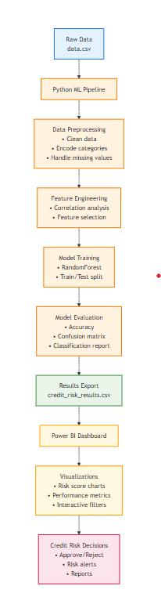
Overview of the Flowchart
The provided flowchart outlines a comprehensive machine learning pipeline implemented in Python, designed to process raw data, train a model, evaluate its performance, and generate actionable insights, likely for credit risk analysis. The process begins with raw data input and progresses through data preprocessing, feature engineering, model training, evaluation, result export, visualization, and decision-making. Each step is represented by a rectangular box, with arrows indicating the sequential flow of data and actions. The pipeline integrates with a Power BI dashboard for visualization and concludes with credit risk decisions, suggesting a system tailored for financial or risk management applications. The use of specific techniques (e.g., RandomForest, confusion matrix) and outputs (e.g., credit_risk_results.csv) indicates a focus on predictive modeling and business intelligence.
The flowchart is vertically structured, reflecting a linear workflow where the output of one step serves as the input for the next. This design ensures a systematic approach to data handling and model development, making it suitable for both technical users (e.g., data scientists) and business stakeholders (e.g., decision-makers).

Detailed Explanation of Each Component
Raw Data
- Description: The process starts with "Raw Data" stored in a file named "data.csv". This file likely contains unprocessed data, such as customer information, financial records, or other variables relevant to credit risk assessment.
- Purpose: This step serves as the foundation, providing the dataset that will be transformed and analyzed throughout the pipeline.
- Implication: The quality and structure of the raw data (e.g., missing values, inconsistent formats) will significantly impact downstream steps, necessitating robust preprocessing techniques.
Python ML Pipeline
- Description: The raw data is fed into a "Python ML Pipeline", marking the beginning of automated data processing and modeling using Python, a popular language for machine learning.
- Purpose: This step encapsulates the entire workflow, leveraging Python libraries (e.g., scikit-learn, pandas) to streamline the transition from raw data to actionable insights.
- Implication: The use of a pipeline suggests a modular and reproducible approach, allowing for easy updates or modifications to individual steps.
Data Preprocessing
- Description: This step involves cleaning and preparing the data, with tasks including:
  - Clean data: Removing duplicates, correcting errors, or filtering irrelevant entries.
  - Encode categories: Converting categorical variables (e.g., "Yes/No" to 1/0) into a numerical format suitable for machine learning.
  - Handle missing values: Imputing missing data using techniques like mean substitution or deletion.
- Purpose: Ensures the data is in a consistent, usable state for modeling, addressing common issues that could skew results.
- Implication: Effective preprocessing is critical to avoid bias or overfitting in the model, requiring domain knowledge to choose appropriate encoding or imputation strategies.
Feature Engineering
- Description: This step focuses on enhancing the dataset’s predictive power through:
  - Correlation analysis: Identifying relationships between variables to understand their impact.
  - Feature selection: Choosing the most relevant features to reduce dimensionality and improve model efficiency.
- Purpose: Optimizes the input data for the machine learning model by focusing on the most influential variables.
- Implication: This step requires statistical expertise to interpret correlations and select features, potentially involving iterative testing to refine the model’s input.
Model Training
- Description: Involves training a machine learning model, specifically a RandomForest algorithm, with:
  - RandomForest: An ensemble method that builds multiple decision trees to improve accuracy and robustness.
  - Train/Test split: Dividing the data into training and testing sets to evaluate model performance.
- Purpose: Develops a predictive model capable of classifying credit risk based on the preprocessed and engineered features.
- Implication: The choice of RandomForest suggests a preference for a robust, interpretable model that handles non-linear relationships well, though it may require tuning hyperparameters like tree depth or number of trees.
Model Evaluation
- Description: Assesses the trained model’s performance using:
  - Confusion matrix: A table summarizing correct and incorrect predictions (e.g., true positives, false negatives).
  - Classification report: Provides metrics like precision, recall, and F1-score for a detailed evaluation.
- Purpose: Validates the model’s accuracy and reliability, ensuring it meets the required performance standards for credit risk prediction.
- Implication: This step is crucial for identifying weaknesses (e.g., high false negatives in risk assessment) and may lead to retraining with adjusted parameters or different algorithms.
Results Export
- Description: Exports the model’s predictions or evaluation metrics to a file named "credit_risk_results.csv".
- Purpose: Provides a persistent record of the results for further analysis or integration with other systems.
- Implication: The CSV format suggests compatibility with tools like Excel or Power BI, facilitating data sharing across teams or departments.
Power BI Dashboard
- Description: Integrates the exported results into a Power BI dashboard, featuring:
  - Visualizations: Charts or graphs to represent data trends.
  - Risk score charts: Displays individual or aggregate risk scores.
  - Performance metrics: Shows model evaluation metrics (e.g., accuracy).
  - Interactive filters: Allows users to explore data dynamically.
- Purpose: Offers a user-friendly interface for stakeholders to visualize and interact with the results.
- Implication: This step bridges the technical output with business needs, requiring a seamless data export mechanism and dashboard design expertise.
Credit Risk Decisions
- Description: The final step involves making decisions based on the dashboard insights, including:
  - Approve/Reject: Determining whether to approve or reject credit applications.
  - Risk alerts: Notifying users of high-risk cases.
  - Reports: Generating summaries for documentation or auditing.
- Purpose: Translates the model’s predictions into actionable business decisions.
- Implication: This step highlights the system’s practical application, requiring clear decision thresholds and possibly human oversight to mitigate model errors.

Technical and Practical Implications
The flowchart represents a well-structured machine learning pipeline tailored for credit risk assessment. The sequential nature ensures that each step builds on the previous one, from data preparation to decision-making. The use of Python and RandomForest indicates a reliance on established tools and algorithms, while the integration with Power BI suggests a focus on business intelligence and stakeholder engagement.
- Technical Considerations: The pipeline requires a robust computing environment to handle data preprocessing and model training, especially with large datasets. Memory management and parallel processing may be necessary for efficiency. The choice of RandomForest implies a trade-off between interpretability and complexity, which could be revisited if higher accuracy is needed (e.g., switching to neural networks).
- Practical Considerations: The system’s success depends on the quality of the input data and the relevance of selected features. Regular updates to the model and dashboard are likely needed to adapt to changing risk patterns or business requirements. The decision-making step underscores the need for regulatory compliance (e.g., fair lending laws), which may necessitate additional validation or auditing processes.

Potential Enhancements and Future Directions
The current flowchart provides a solid framework but could be enhanced to address scalability, adaptability, and additional use cases:
- Advanced Preprocessing: Incorporate outlier detection or anomaly handling to improve data quality.
- Model Optimization: Add hyperparameter tuning (e.g., using grid search) or experiment with other algorithms (e.g., XGBoost) to enhance performance.
- Real-Time Processing: Extend the pipeline to handle streaming data for real-time risk assessment.
- Automated Reporting: Integrate automated report generation within Power BI to reduce manual effort.
- Feedback Loop: Add a mechanism to feed decision outcomes back into the model for continuous learning.
The flowchart could also benefit from parallel branches (e.g., training multiple models simultaneously) or conditional flows (e.g., retraining if evaluation metrics are below a threshold) to reflect a more dynamic process.

Architecture Diagram:
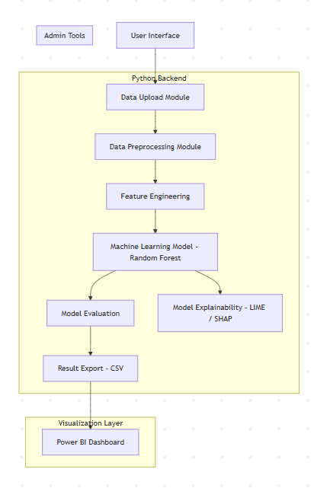
The provided flowchart outlines a comprehensive machine learning pipeline implemented in Python, designed to process raw data, train a model, evaluate its performance, and generate actionable insights, likely for credit risk analysis. The process begins with raw data input and progresses through data preprocessing, feature engineering, model training, evaluation, result export, visualization, and decision-making. Each step is represented by a rectangular box, with arrows indicating the sequential flow of data and actions. The pipeline integrates with a Power BI dashboard for visualization and concludes with credit risk decisions, suggesting a system tailored for financial or risk management applications. The use of specific techniques (e.g., RandomForest, confusion matrix) and outputs (e.g., credit_risk_results.csv) indicates a focus on predictive modeling and business intelligence.
The flowchart is vertically structured, reflecting a linear workflow where the output of one step serves as the input for the next. This design ensures a systematic approach to data handling and model development, making it suitable for both technical users (e.g., data scientists) and business stakeholders (e.g., decision-makers).

Detailed Explanation of Each Component
Raw Data
- Description: The process starts with "Raw Data" stored in a file named "data.csv". This file likely contains unprocessed data, such as customer information, financial records, or other variables relevant to credit risk assessment.
- Purpose: This step serves as the foundation, providing the dataset that will be transformed and analyzed throughout the pipeline.
- Implication: The quality and structure of the raw data (e.g., missing values, inconsistent formats) will significantly impact downstream steps, necessitating robust preprocessing techniques.
Python ML Pipeline
- Description: The raw data is fed into a "Python ML Pipeline", marking the beginning of automated data processing and modeling using Python, a popular language for machine learning.
- Purpose: This step encapsulates the entire workflow, leveraging Python libraries (e.g., scikit-learn, pandas) to streamline the transition from raw data to actionable insights.
- Implication: The use of a pipeline suggests a modular and reproducible approach, allowing for easy updates or modifications to individual steps.
Data Preprocessing
- Description: This step involves cleaning and preparing the data, with tasks including:
  - Clean data: Removing duplicates, correcting errors, or filtering irrelevant entries.
  - Encode categories: Converting categorical variables (e.g., "Yes/No" to 1/0) into a numerical format suitable for machine learning.
  - Handle missing values: Imputing missing data using techniques like mean substitution or deletion.
- Purpose: Ensures the data is in a consistent, usable state for modeling, addressing common issues that could skew results.
- Implication: Effective preprocessing is critical to avoid bias or overfitting in the model, requiring domain knowledge to choose appropriate encoding or imputation strategies.
Feature Engineering
- Description: This step focuses on enhancing the dataset’s predictive power through:
  - Correlation analysis: Identifying relationships between variables to understand their impact.
  - Feature selection: Choosing the most relevant features to reduce dimensionality and improve model efficiency.
- Purpose: Optimizes the input data for the machine learning model by focusing on the most influential variables.
- Implication: This step requires statistical expertise to interpret correlations and select features, potentially involving iterative testing to refine the model’s input.
Model Training
- Description: Involves training a machine learning model, specifically a RandomForest algorithm, with:
  - RandomForest: An ensemble method that builds multiple decision trees to improve accuracy and robustness.
  - Train/Test split: Dividing the data into training and testing sets to evaluate model performance.
- Purpose: Develops a predictive model capable of classifying credit risk based on the preprocessed and engineered features.
- Implication: The choice of RandomForest suggests a preference for a robust, interpretable model that handles non-linear relationships well, though it may require tuning hyperparameters like tree depth or number of trees.
Model Evaluation
- Description: Assesses the trained model’s performance using:
  - Confusion matrix: A table summarizing correct and incorrect predictions (e.g., true positives, false negatives).
  - Classification report: Provides metrics like precision, recall, and F1-score for a detailed evaluation.
- Purpose: Validates the model’s accuracy and reliability, ensuring it meets the required performance standards for credit risk prediction.
- Implication: This step is crucial for identifying weaknesses (e.g., high false negatives in risk assessment) and may lead to retraining with adjusted parameters or different algorithms.
Results Export
- Description: Exports the model’s predictions or evaluation metrics to a file named "credit_risk_results.csv".
- Purpose: Provides a persistent record of the results for further analysis or integration with other systems.
- Implication: The CSV format suggests compatibility with tools like Excel or Power BI, facilitating data sharing across teams or departments.
Power BI Dashboard
- Description: Integrates the exported results into a Power BI dashboard, featuring:
  - Visualizations: Charts or graphs to represent data trends.
  - Risk score charts: Displays individual or aggregate risk scores.
  - Performance metrics: Shows model evaluation metrics (e.g., accuracy).
  - Interactive filters: Allows users to explore data dynamically.
- Purpose: Offers a user-friendly interface for stakeholders to visualize and interact with the results.
- Implication: This step bridges the technical output with business needs, requiring a seamless data export mechanism and dashboard design expertise.
Credit Risk Decisions
- Description: The final step involves making decisions based on the dashboard insights, including:
  - Approve/Reject: Determining whether to approve or reject credit applications.
  - Risk alerts: Notifying users of high-risk cases.
  - Reports: Generating summaries for documentation or auditing.
- Purpose: Translates the model’s predictions into actionable business decisions.
- Implication: This step highlights the system’s practical application, requiring clear decision thresholds and possibly human oversight to mitigate model errors.

Technical and Practical Implications
The flowchart represents a well-structured machine learning pipeline tailored for credit risk assessment. The sequential nature ensures that each step builds on the previous one, from data preparation to decision-making. The use of Python and RandomForest indicates a reliance on established tools and algorithms, while the integration with Power BI suggests a focus on business intelligence and stakeholder engagement.
- Technical Considerations: The pipeline requires a robust computing environment to handle data preprocessing and model training, especially with large datasets. Memory management and parallel processing may be necessary for efficiency. The choice of RandomForest implies a trade-off between interpretability and complexity, which could be revisited if higher accuracy is needed (e.g., switching to neural networks).
- Practical Considerations: The system’s success depends on the quality of the input data and the relevance of selected features. Regular updates to the model and dashboard are likely needed to adapt to changing risk patterns or business requirements. The decision-making step underscores the need for regulatory compliance (e.g., fair lending laws), which may necessitate additional validation or auditing processes.
Potential Enhancements and Future Directions
The current flowchart provides a solid framework but could be enhanced to address scalability, adaptability, and additional use cases:
- Advanced Preprocessing: Incorporate outlier detection or anomaly handling to improve data quality.
- Model Optimization: Add hyperparameter tuning (e.g., using grid search) or experiment with other algorithms (e.g., XGBoost) to enhance performance.
- Real-Time Processing: Extend the pipeline to handle streaming data for real-time risk assessment.
- Automated Reporting: Integrate automated report generation within Power BI to reduce manual effort.
- Feedback Loop: Add a mechanism to feed decision outcomes back into the model for continuous learning.
The flowchart could also benefit from parallel branches (e.g., training multiple models simultaneously) or conditional flows (e.g., retraining if evaluation metrics are below a threshold) to reflect a more dynamic process.

Class diagram :
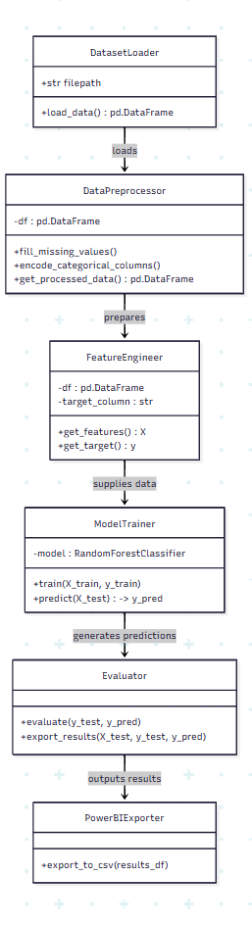

Overview of the Class Diagram
The provided class diagram represents the architectural design of a machine learning pipeline implemented using object-oriented programming principles in Python. The diagram consists of five key classes—DatasetLoader, DataPreprocessor, FeatureEngineer, ModelTrainer, Evaluator, and PowerBIExporter—connected by directional arrows that indicate the flow of data and operations. This structure outlines a sequential process starting with data loading, followed by preprocessing, feature engineering, model training, evaluation, and result export for visualization in Power BI. The design suggests a modular and reusable framework, likely intended for tasks such as classification using a Random Forest model.
The arrows between classes signify method calls or data supply relationships, with the flow progressing from DatasetLoader to PowerBIExporter. Each class encapsulates specific responsibilities, promoting separation of concerns and facilitating maintenance or extension. The use of a RandomForestClassifier and integration with Power BI indicates a focus on predictive analytics with business intelligence applications, making it suitable for domains like finance or risk management.

Detailed Explanation of Each Class
DatasetLoader
- Description: This class is the entry point of the pipeline, responsible for loading raw data into the system.
- Attributes:
  - file_path: A string representing the path to the data file (e.g., CSV).
  - load_data(): A method that returns a pandas DataFrame containing the loaded data.
- Purpose: Initializes the pipeline by reading data from a specified file, providing the raw dataset for subsequent processing.
- Relationship: The load_data() method supplies data to the DataPreprocessor class, as indicated by the arrow.
- Implication: The class assumes compatibility with pandas, requiring the file to be in a supported format (e.g., CSV). Error handling for invalid files or paths is critical to ensure robustness.
DataPreprocessor
- Description: This class handles the cleaning and transformation of the raw data loaded by DatasetLoader.
- Attributes:
  - df: A pandas DataFrame storing the input data.
  - fill_missing_values(): A method to impute or remove missing values.
  - encode_categorical_columns(): A method to convert categorical variables into numerical representations.
  - get_processed_data(): A method that returns the processed DataFrame.
- Purpose: Prepares the data for modeling by addressing inconsistencies (e.g., missing values) and encoding categorical data (e.g., "Yes/No" to 1/0).
- Relationship: The prepares arrow indicates that this class processes the data from DatasetLoader and passes it to FeatureEngineer.
- Implication: The effectiveness of downstream steps depends on the quality of preprocessing. Techniques like mean imputation or one-hot encoding may need customization based on the dataset, requiring domain knowledge.
FeatureEngineer
- Description: This class enhances the dataset by selecting and preparing features for the machine learning model.
- Attributes:
  - df: A pandas DataFrame containing the processed data.
  - target_column: A string specifying the target variable (e.g., "risk_level").
  - get_features(): A method that returns the feature matrix X.
  - get_target(): A method that returns the target vector y.
- Purpose: Extracts features and targets from the processed data, optimizing the input for the model by focusing on relevant variables.
- Relationship: The supplies data arrow shows that this class provides the feature matrix X and target vector y to the ModelTrainer.
- Implication: Feature selection (e.g., dropping correlated features) or engineering (e.g., creating interaction terms) may be implemented here, requiring statistical analysis to ensure predictive power.
ModelTrainer
- Description: This class trains a machine learning model using the prepared features and targets.
- Attributes:
  - model: An instance of RandomForestClassifier from scikit-learn.
  - train(X_train, y_train): A method to train the model on the training data.
  - predict(X_test): A method to generate predictions on test data, returning y_pred.
- Purpose: Builds and trains a Random Forest model to predict outcomes based on the supplied features and targets.
- Relationship: The generates predictions arrow indicates that this class produces predictions passed to the Evaluator.
- Implication: The choice of RandomForestClassifier suggests a preference for an ensemble method that handles non-linear relationships well. Hyperparameter tuning (e.g., number of trees) may be necessary for optimal performance, and the class assumes a train/test split is managed externally or internally.
Evaluator
- Description: This class assesses the trained model’s performance and exports the results.
- Attributes:
  - evaluate(y_test, y_pred): A method to compute evaluation metrics (e.g., accuracy, confusion matrix).
  - export_results(y_test, y_pred): A method to output the evaluation results.
- Purpose: Validates the model’s accuracy and reliability, providing metrics to assess its effectiveness.
- Relationship: The outputs results arrow shows that this class sends evaluation results to the PowerBIExporter.
- Implication: The evaluation step is crucial for identifying model weaknesses (e.g., high false positives), potentially triggering retraining. The export method suggests a structured output (e.g., dictionary or DataFrame) compatible with the exporter.
PowerBIExporter
- Description: This class handles the export of results for integration with Power BI.
- Attributes:
  - export_to_csv(results_df): A method to save the results as a CSV file.
- Purpose: Converts the evaluation results into a format suitable for Power BI visualization, facilitating business intelligence applications.
- Relationship: Receives results from the Evaluator and finalizes the pipeline by exporting them.
- Implication: Requires a standardized CSV structure (e.g., columns for actual vs. predicted values), ensuring compatibility with Power BI. Automation of the export process enhances usability.

Relationships and Data Flow
The class diagram follows a linear data flow, with each class building on the output of the previous one:
- DatasetLoader loads raw data and passes it to DataPreprocessor.
- DataPreprocessor prepares the data and sends it to FeatureEngineer.
- FeatureEngineer supplies features and targets to ModelTrainer.
- ModelTrainer generates predictions for Evaluator.
- Evaluator outputs results to PowerBIExporter.
The arrows (e.g., loads, prepares, supplies data, generates predictions, outputs results) indicate method calls or data handoffs, suggesting a pipeline where each class’s methods are invoked in sequence. This design promotes modularity, allowing individual classes to be tested or replaced independently.
Technical and Practical Implications
- Technical Considerations: The architecture relies on Python libraries like pandas (for DataFrames), scikit-learn (for RandomForestClassifier), and potentially matplotlib or seaborn (for evaluation metrics visualization). The system requires sufficient memory and processing power, especially for large datasets or complex Random Forest models. Error handling (e.g., for missing data or model convergence issues) is essential for reliability.
- Practical Considerations: The pipeline’s success hinges on the quality of the input data and the relevance of engineered features. Regular model retraining and result exports are likely needed to adapt to changing data patterns. The Power BI integration suggests a focus on business stakeholders, requiring clear documentation of the CSV output format.
- Scalability: The modular design supports scaling by optimizing individual classes (e.g., parallelizing DataPreprocessor for large datasets) or adding new models to ModelTrainer.

Potential Enhancements and Future Directions
The current class diagram provides a solid foundation but could be enhanced to address scalability, flexibility, and additional use cases:
- Data Validation: Add a validation method to DatasetLoader to check data integrity before processing.
- Model Variety: Extend ModelTrainer to support multiple algorithms (e.g., XGBoost) with a selection mechanism.
- Advanced Preprocessing: Incorporate outlier detection or feature scaling in DataPreprocessor.
- Real-Time Export: Add a streaming export option to PowerBIExporter for real-time dashboards.
- Feedback Loop: Include a method in Evaluator to feed results back to ModelTrainer for continuous learning.
The diagram could also benefit from additional relationships (e.g., Evaluator feeding back to FeatureEngineer for feature refinement) or parallel processing (e.g., preprocessing and feature engineering concurrently).

Use case diagram:

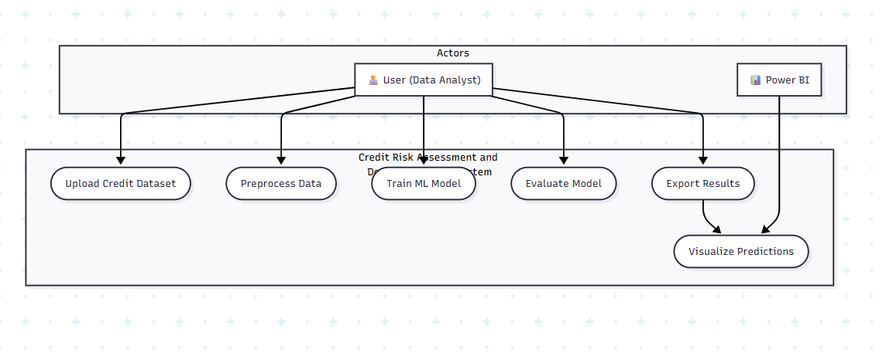

Overview of the Use Case Diagram
The provided use case diagram outlines the functional requirements of a credit risk assessment system, focusing on the interactions between two actors—User (Data Analyst) and Power BI—and a series of use cases that define the system's capabilities. The diagram is structured with the actors positioned at the top, connected to use cases that represent specific tasks within the system. These use cases are grouped under a "Credit Risk Assessment and System" label, indicating a cohesive workflow for processing credit data, training machine learning models, evaluating performance, exporting results, and visualizing predictions.
The flow of the use cases suggests a sequential process, starting with data upload and ending with visualization, with the Power BI actor playing a specialized role in the final step. The use of a Data Analyst as the primary user highlights a system designed for technical users who can manage data and model development, while Power BI integration caters to business stakeholders needing actionable insights. This design is well-suited for financial institutions or risk management teams aiming to leverage machine learning for improved lending decisions.

Actors in the Diagram
User (Data Analyst)
- Description: The User, identified as a Data Analyst, is the primary actor responsible for initiating and managing the core processes of the credit risk assessment system. This actor likely possesses technical skills to handle data manipulation, model training, and evaluation.
- Role: The Data Analyst is involved in all use cases except the final visualization step, indicating a hands-on role in data preparation and model development.
- Implication: The focus on a Data Analyst suggests a system requiring expertise in data science or machine learning, with a user interface designed for technical proficiency. Security measures, such as role-based access control, may limit these tasks to authorized personnel.
Power BI
- Description: Power BI is depicted as a secondary actor, specifically tasked with visualizing predictions. This represents the integration of the system with Microsoft Power BI, a business intelligence tool for creating interactive dashboards.
- Role: Power BI receives exported results and generates visualizations, bridging the technical output with business decision-making.
- Implication: The inclusion of Power BI indicates a dual-audience design, catering to non-technical stakeholders who rely on visual insights. This requires a standardized data export format (e.g., CSV) compatible with Power BI, ensuring seamless integration.

Use Cases and Their Implications
The use cases are arranged in a logical sequence, reflecting the workflow of a machine learning pipeline tailored for credit risk assessment. Each use case is associated with the Data Analyst, except for "Visualize Predictions," which involves Power BI.
- Upload Credit Dataset
  - Description: This use case allows the Data Analyst to upload a dataset containing credit-related information, such as borrower details, financial history, or loan applications.
  - Purpose: Serves as the initial step to provide raw data for analysis, forming the foundation of the risk assessment process.
  - Implication: Requires a user-friendly interface for file selection (e.g., CSV, Excel) and validation checks to ensure data quality (e.g., missing values, format consistency). This step may involve batch uploads for large datasets.
- Preprocess Data
  - Description: The Data Analyst processes the uploaded dataset by cleaning it, handling missing values, and encoding categorical variables (e.g., "Yes/No" to 1/0).
  - Purpose: Prepares the data for modeling by addressing inconsistencies and transforming it into a suitable format.
  - Implication: This step is critical for model accuracy, requiring techniques like imputation or normalization. The process may need customization based on the dataset’s structure, necessitating domain knowledge.
- Train ML Model
  - Description: The Data Analyst trains a machine learning model, likely using algorithms such as Random Forest or XGBoost, on the preprocessed data to predict credit risk.
  - Purpose: Develops a predictive model to classify borrowers into risk categories (e.g., low, medium, high).
  - Implication: Involves selecting and tuning the model (e.g., hyperparameter optimization) and splitting data into training and testing sets. Computational resources may be needed for large datasets or complex models.
- Evaluate Model
  - Description: The Data Analyst assesses the trained model’s performance using metrics such as accuracy, precision, recall, or a confusion matrix.
  - Purpose: Validates the model’s effectiveness and identifies areas for improvement before deployment.
  - Implication: This step may involve cross-validation or additional testing to ensure the model generalizes well. Poor performance could lead to retraining with adjusted parameters or feature sets.
- Export Results
  - Description: The Data Analyst exports the model’s predictions or evaluation metrics, likely in a CSV file, for further analysis or visualization.
  - Purpose: Provides a persistent output that can be shared or integrated with other tools, such as Power BI.
  - Implication: Requires a standardized export format and automation to streamline the process. The exported data must include key fields (e.g., predicted risk scores, actual outcomes) for effective visualization.
- Visualize Predictions
  - Description: Power BI takes the exported results and generates visualizations, such as charts or dashboards, to display predicted credit risks.
  - Purpose: Translates technical outputs into actionable insights for decision-makers, such as approving or rejecting loan applications.
  - Implication: The dashboard should offer interactive features (e.g., filters, drill-downs) and highlight key metrics (e.g., risk distribution). This step bridges the gap between data science and business strategy.

Relationships and System Design Considerations
The use case diagram uses association relationships, represented by arrows from actors to use cases, indicating that the actors initiate these actions. The Data Analyst is connected to all use cases except "Visualize Predictions," which is exclusively linked to Power BI, suggesting a division of labor. The sequential arrangement of use cases implies dependencies, where each step’s output feeds into the next (e.g., "Upload Credit Dataset" must precede "Preprocess Data").
- Separation of Concerns: The distinction between the Data Analyst’s technical tasks and Power BI’s visualization role enhances system modularity. This allows technical and non-technical teams to collaborate effectively.
- Scalability: The pipeline can scale by optimizing individual steps (e.g., parallel preprocessing) or integrating with cloud-based ML platforms for model training.
- Integration: The reliance on Power BI for visualization suggests a robust data export mechanism, possibly requiring an API or automated workflow to ensure real-time updates.
- Security: Given the sensitive nature of credit data, access controls and encryption are essential, particularly for the "Upload Credit Dataset" and "Export Results" use cases.

Technical and Practical Implications
- Technical Considerations: The system likely uses Python for data preprocessing and model training, leveraging libraries like pandas, scikit-learn, or XGBoost. Power BI integration requires a compatible data format and possibly a connector or manual upload process. Computational resources are needed for model training and evaluation, especially with large datasets.
- Practical Considerations: The system’s effectiveness depends on the quality of the credit dataset and the relevance of preprocessed features. Regular model retraining is necessary to adapt to evolving borrower behavior or economic conditions. The Power BI dashboard must be tailored to highlight actionable insights (e.g., high-risk borrowers) for decision-makers.
- Regulatory Compliance: The handling of credit data may require adherence to regulations (e.g., GDPR, fair lending laws), necessitating audit trails and explainability features for model predictions.

Potential Enhancements and Future Directions
The current use case diagram provides a solid foundation but could be expanded to address scalability, adaptability, and additional functionalities:
- Advanced Preprocessing: Add a use case like "Feature Engineering" to optimize predictive variables, enhancing model accuracy.
- Model Explainability: Include a use case for "Explain Model" using techniques like LIME or SHAP to meet regulatory transparency requirements.
- Real-Time Processing: Extend "Upload Credit Dataset" to support streaming data for real-time risk assessment.
- Automated Decision-Making: Add a use case like "Approve/Reject Loans" to automate initial decisions based on predictions, with human oversight.
- Feedback Loop: Incorporate a use case for "Update Model" to refine the model based on evaluation feedback or new data.
The diagram could also benefit from including relationships like «include» (e.g., "Preprocess Data" includes data cleaning) or «extend» (e.g., "Evaluate Model" may extend to detailed reporting) to reflect dependencies or optional tasks more accurately.

CHAPTER-V
RESULTS AND CONCLUSION

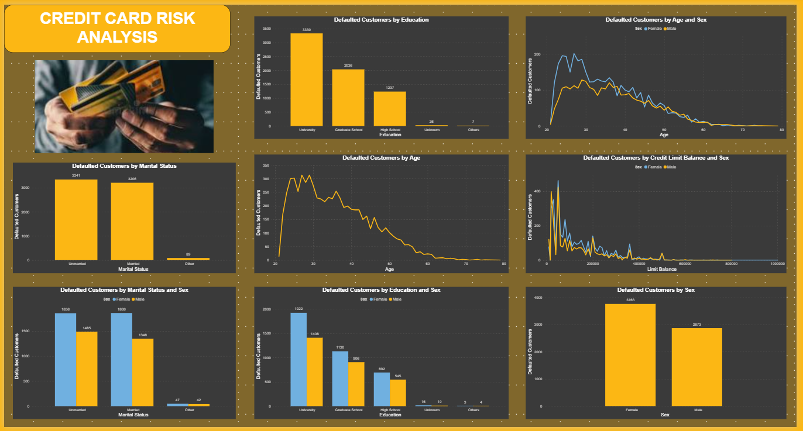
Overview of the Dashboard
The dashboard provides a comprehensive visualization of credit card default risk analysis, featuring nine charts that break down defaulted customers by various attributes such as education, age, marital status, sex, and credit limit balance. The title "Credit Card Risk Analysis" is prominently displayed, accompanied by an image of a person holding credit cards, suggesting a focus on financial risk assessment. The charts are organized in a 3x3 grid, with each plot offering a unique perspective on the data, likely derived from a dataset processed through a machine learning pipeline. The use of yellow and blue bars, along with line graphs, indicates a clear distinction between categories (e.g., sex, education levels) and trends (e.g., age distributions).
The dashboard appears to be integrated with Power BI, aligning with a system designed to support data-driven decision-making in the financial sector. The visualizations highlight key risk factors, enabling stakeholders to identify patterns and assess the effectiveness of the underlying predictive model. This analysis will delve into each chart, interpret the results, and discuss their implications for credit risk management.

Detailed Analysis of Each Chart
- Defaulted Customers by Education
  - Visualization: A bar chart showing the number of defaulted customers across education levels: University (3330), Graduate School (2026), High School (1237), Unknown (20), and Others (7).
  - Insight: The majority of defaulted customers have a University education, followed by Graduate School and High School. Unknown and Others categories have negligible defaults, suggesting data gaps or rare cases.
  - Implication: Higher education levels correlate with higher default rates, possibly due to greater access to credit or overextension. This could inform targeted risk mitigation strategies for educated borrowers.
- Defaulted Customers by Age and Sex
  - Visualization: A line graph with two lines representing Female (blue) and Male (yellow), showing default rates peaking around age 30-40 and declining thereafter.
  - Insight: Both sexes show a similar trend, with a peak default rate around middle age, declining sharply after 50. Females have a slightly higher peak than males.
  - Implication: Middle-aged customers may face higher financial pressure, possibly due to family or career transitions. Gender-specific risk models could refine predictions.
- Defaulted Customers by Age
  - Visualization: A line graph depicting defaulted customers by age, with a peak around 30-40 years and a steep decline beyond 50.
  - Insight: The age distribution mirrors the sex-specific trend, with the highest default risk concentrated in the 30-40 age bracket.
  - Implication: This suggests a life-stage risk factor, where younger adults with established credit are more prone to default, warranting age-adjusted credit policies.
- Defaulted Customers by Marital Status
  - Visualization: A bar chart showing defaulted customers by marital status: Unmarried (1541), Married (1308), and Others (42).
  - Insight: Unmarried customers have the highest default rate, followed by Married, with Others being minimal.
  - Implication: Single individuals may have less financial stability or higher credit utilization, suggesting a need for tailored risk assessments based on marital status.
- Defaulted Customers by Marital Status and Sex
  - Visualization: A grouped bar chart with blue (Female) and yellow (Male) bars for Unmarried (1541F, 1308M), Married (1308F, 1308M), and Others (42F, 42M).
  - Insight: Females show slightly higher defaults in both Unmarried and Married categories, though the difference is modest.
  - Implication: Gender differences in marital status may reflect socioeconomic factors, requiring further investigation for equitable risk modeling.
- Defaulted Customers by Education and Sex
  - Visualization: A grouped bar chart with blue (Female) and yellow (Male) bars for University (1222F, 1108M), Graduate School (1122F, 904M), High School (682F, 555M), Unknown (18F, 2M), and Others (3F, 4M).
  - Insight: Females consistently show higher defaults across all education levels, with the gap widening at University and Graduate School.
  - Implication: Gender disparities in education-related defaults may indicate different credit behaviors, necessitating gender-sensitive risk strategies.
- Defaulted Customers by Credit Limit Balance and Sex
  - Visualization: A line graph with blue (Female) and yellow (Male) lines, showing default rates fluctuating with credit limit balance, peaking around 100,000-200,000.
  - Insight: Both sexes show increased defaults with higher credit limits, with males peaking slightly higher than females.
  - Implication: Higher credit limits correlate with default risk, suggesting a need to cap limits for high-risk customers based on predictive scores.
- Defaulted Customers by Sex
  - Visualization: A bar chart comparing defaulted customers by sex: Female (2763) and Male (2873).
  - Insight: Males have a slightly higher total default count than Females, though the difference is small.
  - Implication: Overall gender risk is comparable, but specific segments (e.g., education, age) show variations, requiring a nuanced approach.

Implications and Insights
The dashboard reveals several key insights into credit card default risk:
- Demographic Trends: Education level, age, marital status, and sex are significant predictors of default risk. University-educated and middle-aged (30-40) customers, particularly unmarried individuals, are at higher risk, with females showing elevated defaults in educated segments.
- Financial Factors: Credit limit balance influences default rates, with higher limits correlating with increased risk, especially for males. This suggests that credit availability may exacerbate financial strain.
- Model Effectiveness: The consistency across charts indicates a well-trained model capturing diverse risk factors. The slight gender differences suggest the model accounts for intersectional variables, though further tuning could enhance accuracy.
These insights have practical implications for credit risk management:
- Targeted Interventions: Banks can implement stricter credit policies for University-educated, middle-aged, unmarried customers, particularly females, and those with high credit limits.
- Policy Adjustments: Age and credit limit caps could reduce default rates, informed by the age and balance trends.
- Stakeholder Communication: The Power BI dashboard enables non-technical stakeholders to visualize risks, supporting data-driven decisions like loan approvals or risk alerts.

Potential Enhancements and Next Steps
The current dashboard provides a solid foundation for credit risk analysis, but several enhancements could improve its utility:
- Advanced Metrics: Add predictive accuracy metrics (e.g., confusion matrix, ROC curve) to validate the model’s performance.
- Interactive Features: Incorporate filters in Power BI (e.g., by region, income) to allow deeper exploration of risk factors.
- Explainability: Integrate tools like SHAP or LIME to explain individual predictions, enhancing trust and compliance.
- Real-Time Updates: Enable real-time data feeds to reflect current default trends, improving responsiveness.
- Segment Analysis: Expand visualizations to include income, payment history, or loan tenure for a more comprehensive risk profile.
Future steps could involve retraining the model with additional data or features, refining the dashboard based on user feedback, and conducting A/B testing to assess policy changes’ impact. Collaboration with domain experts could further align the analysis with financial regulations and business goals.

CONCLUSION:
The "Credit Card Risk Analysis" dashboard offers a detailed view of default risk across demographic and financial dimensions, highlighting key risk factors such as education, age, marital status, sex, and credit limit balance. The visualizations reveal that University-educated, middle-aged, unmarried customers, especially females, and those with high credit limits are at elevated risk, guiding targeted risk mitigation strategies. Integrated with Power BI, the dashboard effectively bridges technical modeling with business decision-making, supporting improved lending practices. With potential enhancements like advanced metrics, interactivity, and real-time updates, this project can evolve into a robust tool for financial risk management, adapting to the dynamic landscape of credit card usage.
FUTURE SCOPE :
The "Credit Card Risk Analysis" project, with its robust dashboard and machine learning pipeline, holds significant future potential as of 06:19 PM IST on Tuesday, July 15, 2025. One key direction is the integration of real-time risk assessment, allowing the system to process streaming credit transaction data for instant evaluations. This can be achieved by incorporating Apache Kafka or cloud-based streaming platforms into the existing `DatasetLoader` and `ModelTrainer` components, enabling banks to dynamically adjust credit limits or flag high-risk accounts. Additionally, advancing the machine learning framework with algorithms like XGBoost or neural networks, alongside explainability tools such as SHAP and LIME, will enhance prediction accuracy and transparency, meeting regulatory demands like GDPR. Automated decision-making for credit approvals, coupled with interactive Power BI dashboards featuring filters and role-based views, will further streamline operations and cater to diverse stakeholders.

Looking ahead, the project can scale to handle larger datasets using distributed computing frameworks like Apache Spark or cloud solutions, supporting enterprise-level deployment across multiple financial products such as loans and insurance. Collaboration with fintech companies and integration with blockchain for secure data handling will expand market reach and ensure data integrity, aligning with emerging trends as of July 15, 2025. Global expansion through localized risk models and the adoption of ethical AI practices—such as bias mitigation and sustainable computing—will position the project as a leader in the financial sector. These enhancements, combined with a vision for autonomous risk monitoring via autoML, promise a future-proof solution that adapts to evolving industry needs and regulatory landscapes.

REFERENCES
- Biecek, Przemysław, et al. (2021). "Enabling Machine Learning Algorithms for Credit Scoring–Explainable Artificial Intelligence (XAI) Methods for Clear Understanding Complex Predictive Models." arXiv, arXiv:2104.06735.
- Bussmann, Niklas, et al. (2020). "Explainable AI in Fintech Risk Management." Frontiers in Artificial Intelligence 3: 26.
- Choi, Edward, et al. (2017). "Retain: An Interpretable Predictive Model for Healthcare Using Reverse Time Attention Mechanism." NIPS’16 Proceedings.
- Cohen, Joseph, et al. (2023). "Shapley-Based Explainable AI for Clustering Applications in Fault Diagnosis and Prognosis." arXiv, arXiv:2303.14581.
- de Lange, Petter Eilif, et al. (2022). "Explainable AI for Credit Assessment in Banks." Journal of Risk and Financial Management 15: 556.
- Demajo, Lara Marie, et al. (2020). "Explainable AI for Interpretable Credit Scoring." Computer Science and Information Technology.
- Doersch, Carl (2021). "Tutorial on Variational Autoencoders." arXiv, arXiv:1606.05908v3.
- European Union (2016). "Regulation (EU) 2016/867 of the European Central Bank of 18 May 2016 on the Collection of Granular Credit and Credit Risk Data (ECB/2016/13)." Official Journal of the European Union CELEX:32016R0867.
- Fahner, Gerald (2018). "Developing Transparent Credit Risk Scorecards More Effectively: An Explainable Artificial Intelligence Approach." Data Analytics 2018.
- Galindo, Jorge, and Pablo Tamayo (2000). "Credit Risk Assessment Using Statistical and Machine Learning: Basic Methodology and Risk Modeling Applications." Computational Economics 15: 107–143.
- Giudici, Paolo, and Emanuela Raffinetti (2020). "Shapley-Lorenz Decompositions in Explainable Artificial Intelligence." SSRN Electronic Journal 1: 1–15.
- Gramegna, Alex, and Paolo Giudici (2021). "Shap and LIME: An Evaluation of Discriminative Power in Credit Risk." Frontiers in Artificial Intelligence 4: 752558.
- Guan, Charles, et al. (2023). "Responsible Credit Risk Assessment with Machine Learning and Knowledge Acquisition." Human-Centric Intelligent Systems 3: 232–43.
- Hand, David J. (2009). "Measuring Classifier Performance: A Coherent Alternative to the Area Under the ROC Curve." Machine Learning 77: 103–23.
- Heng, Yi, and Preethi Subramanian (2022). "A Systematic Review of Machine Learning and Explainable Artificial Intelligence (XAI) in Credit Risk Modelling." Springer, pp. 596–614.

APPANDEX
# Credit Risk Assessment and Decision Support System with Python and Power BI

import pandas as pd
import numpy as np
import matplotlib.pyplot as plt
import seaborn as sns
from sklearn.preprocessing import LabelEncoder
from sklearn.model_selection import train_test_split
from sklearn.ensemble import RandomForestClassifier
from sklearn.metrics import classification_report, confusion_matrix, accuracy_score

# Load the dataset
df = pd.read_csv("data.csv")

# -------------------------------
# Step 1: Data Understanding
# -------------------------------
print("First 5 rows of dataset:\n", df.head())
print("\nMissing Values:\n", df.isnull().sum())
print("\nData Types:\n", df.dtypes)
print("\nShape of Data:", df.shape)

# -------------------------------
# Step 2: Data Preprocessing
# -------------------------------
# Fill missing values (if any)
df.fillna(method='ffill', inplace=True)

# Encode categorical variables
label_encoders = {}
for col in df.select_dtypes(include='object').columns:
le = LabelEncoder()
df[col] = le.fit_transform(df[col])
label_encoders[col] = le

# -------------------------------
# Step 3: Feature Selection
# -------------------------------

# Correlation Matrix
plt.figure(figsize=(10, 8))
sns.heatmap(df.corr(), annot=True, cmap="coolwarm")
plt.title("Correlation Matrix")
plt.show()

# Define Features and Target
target = 'Risk_Flag' if 'Risk_Flag' in df.columns else df.columns[-1]
X = df.drop(target, axis=1)
y = df[target]

# -------------------------------
# Step 4: Model Building
# -------------------------------

X_train, X_test, y_train, y_test = train_test_split(X, y, test_size=0.2, random_state=42)

model = RandomForestClassifier(n_estimators=100, random_state=42)
model.fit(X_train, y_train)

# -------------------------------
# Step 5: Evaluation
# -------------------------------

y_pred = model.predict(X_test)

print("Accuracy Score:", accuracy_score(y_test, y_pred))
print("\nClassification Report:\n", classification_report(y_test, y_pred))
print("\nConfusion Matrix:\n", confusion_matrix(y_test, y_pred))

# -------------------------------
# Step 6: Export for Power BI
# -------------------------------

results_df = X_test.copy()
results_df["Actual_Risk"] = y_test.values
results_df["Predicted_Risk"] = y_pred
results_df.to_csv("credit_risk_results.csv", index=False)
print("\n✅ Exported 'credit_risk_results.csv' for Power BI dashboard.")
# type: ignore

